DEFENDER TECHNICAL DEEP DIVE
CVE-2026-34486: Apache Tomcat EncryptInterceptor Bypass
CISA-Confirmed Exploitation in an AI-Orchestrated Chinese Threat Campaign

Root cause analysis • Version matrix • Evidence of exploitation
Detection guidance • Interim mitigations • BOD 26-04 compliance context
9.8 | 81.16% | Aug 7, 2026
CVSS (NVD/CISA-ADP) | EPSS, 99.6th pct. | BOD 26-04 due date

Defender-focused report — August 2026

Contents

1. Executive summary
2. Timeline
3. Technical root cause and exploitation path
4. Affected and fixed version matrix
5. Evidence of exploitation and public exploit code
6. The AI-orchestrated campaign, in full
7. Detection guidance
8. Interim mitigations for teams that cannot patch immediately
9. Regulatory and compliance context: CISA KEV and BOD 26-04
10. Open questions and limitations of current evidence
Sources

1. Executive summary

On August 4–5, 2026, the U.S. Cybersecurity and Infrastructure Security Agency (CISA) added CVE-2026-34486 — a "Missing Encryption of Sensitive Data" flaw in Apache Tomcat's clustering component — to its Known Exploited Vulnerabilities (KEV) catalog, alongside a Langflow remote-code-execution bug (CVE-2026-9198) and two N-able N-central authentication-bypass flaws (CVE-2026-18556 and CVE-2026-18577), per CISA's own KEV data feed and its alert on the addition. Federal civilian agencies were given a due date of August 7, 2026 to remediate under Binding Operational Directive (BOD) 26-04, the directive that in mid-2026 replaced BOD 22-01 as CISA's vulnerability-remediation framework.
CVE-2026-34486 is a regression: it is a bypass of the fix Apache shipped for an earlier, related flaw, CVE-2026-29146, a padding-oracle weakness in Tomcat's EncryptInterceptor clustering-encryption component. The patch for CVE-2026-29146 inadvertently moved a line of message-processing code outside its try/catch block, so that when decryption of a cluster message fails, Tomcat now logs an error but still forwards the raw, unencrypted, unauthenticated bytes into the Java deserialization path — turning a defense-in-depth encryption control into a fail-open pre-authentication deserialization sink on any Tomcat node reachable on its clustering port (default TCP/4000). Independent researchers reconstructed the vulnerable code path from Apache's own commits and published working proof-of-concept (PoC) exploits generating remote code execution via a Commons Collections 6 (CC6) Java deserialization gadget chain — see the striga.ai technical writeup and the striga-ai and 404-src GitHub PoC repositories.
Separately, and roughly a week before CISA's KEV addition, Palo Alto Networks' Unit 42 published research attributing active exploitation attempts against CVE-2026-34486 to a Chinese-speaking threat actor ("knaithe" / "KnYuan", assessed to be based in Zhuhai, China) who ran a broader, partly AI-orchestrated attack campaign using DeepSeek models through an open-source agent framework called Hermes Agent — see Unit 42, "Chinese-Speaking Threat Actor Harnesses AI Models for Autonomous Cyberattacks," July 30, 2026. Within that campaign, the actor's exploitation of Apache Tomcat via CVE-2026-34486 was conducted manually (not autonomously by the AI agent), attempting Java-deserialization-based reverse shells against nine internet-exposed Tomcat servers.
Defenders should keep two distinct facts separate, since press coverage often merges them: (1) CISA's KEV listing is CISA's own confirmation that CVE-2026-34486 is being exploited in the wild; (2) the attribution of that exploitation to a specific AI-orchestrated Chinese actor is Unit 42's independent research finding, published separately from CISA's bulletin, which does not itself name the actor, the AI tooling, or Unit 42 in its KEV entry text (CISA KEV feed; thehackernews.com summary).
This report gives defenders everything needed to triage the flaw: the exact code-level root cause, the full three-branch version matrix, what is and is not verified about exploitation, concrete log signatures and network indicators, a published detection template, and the interim controls to apply if an immediate upgrade is not possible.

2. Timeline

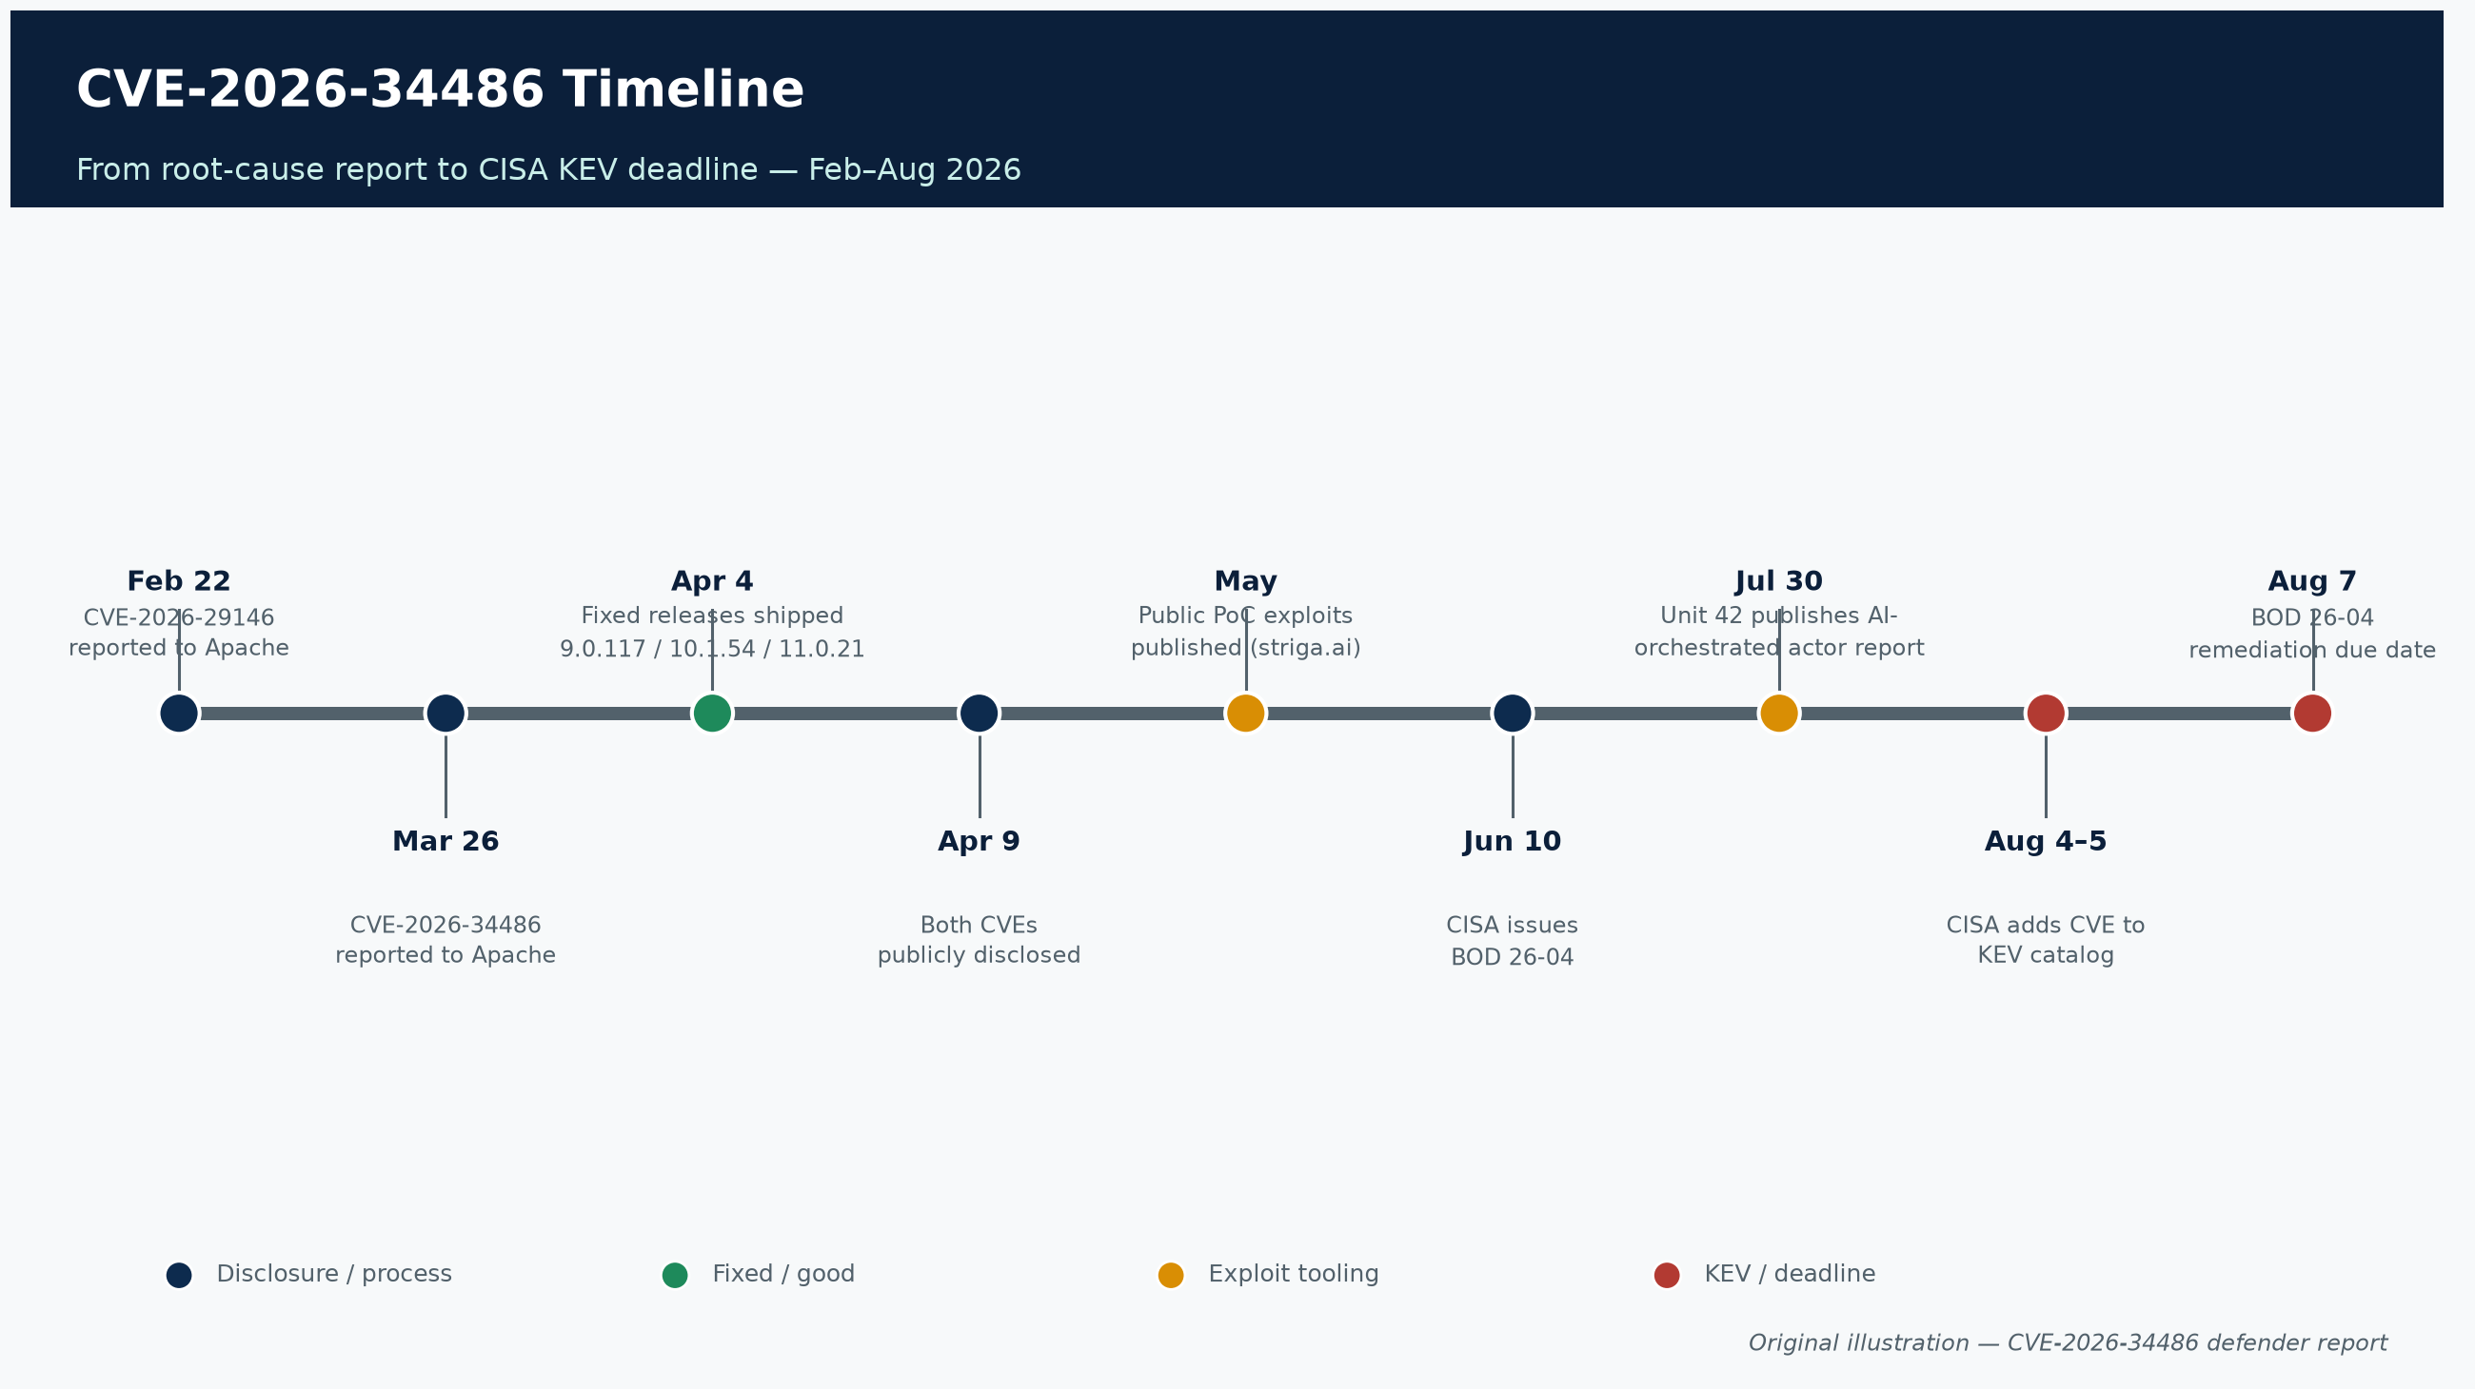
Figure 1. CVE-2026-34486 timeline, February–August 2026. Original illustration — CVE-2026-34486 defender report.
Date (2026) | Event | Source
Feb 22 | CVE-2026-29146 (EncryptInterceptor padding-oracle) reported to the Apache Tomcat security team | tomcat.apache.org/security-11.html
Mar 26 | CVE-2026-34486 (EncryptInterceptor bypass regression) reported to the Apache Tomcat security team | tomcat.apache.org/security-11.html
Apr 4 | Fixed Tomcat releases (9.0.117, 10.1.54, 11.0.21) published, patching both CVEs | GHSA-69r9-qgr7-g2wj; SocRadar
Apr 9 | Both CVEs publicly disclosed by the Apache Tomcat security team | security-9, -10, -11
May 2026 | Public PoC exploit code for CVE-2026-34486 released on GitHub (striga-ai research and PoC) | striga.ai; Field Effect
Jun 10 | CISA issues BOD 26-04, superseding BOD 19-02/22-01 | CISA BOD 26-04
Jul 30 | Unit 42 publishes "Chinese-Speaking Threat Actor Harnesses AI Models for Autonomous Cyberattacks," documenting manual exploitation attempts by actor "knaithe"/"KnYuan" | Unit 42
Aug 4–5 | CISA adds CVE-2026-34486, CVE-2026-9198, CVE-2026-18556 and CVE-2026-18577 to the KEV catalog; due date set for Aug 7 | CISA KEV feed
Aug 7 | BOD 26-04 remediation due date for FCEB agencies | CISA KEV feed

3. Technical root cause and exploitation path

3.1 Background: Tomcat's clustering component and the encryption it was supposed to add
Apache Tomcat ships an optional clustering subsystem called Tribes (org.apache.catalina.tribes), used to replicate sessions and other state across nodes in a Tomcat cluster. Tribes messages traditionally traveled unauthenticated and unencrypted between cluster members; the EncryptInterceptor was added as an opt-in channel interceptor to give cluster traffic confidentiality and integrity using a pre-shared symmetric key, so that clustering could be run over networks the operator does not fully trust (Oligo Security).

3.2 CVE-2026-29146 — the padding-oracle flaw that started the chain
By default, EncryptInterceptor used AES in CBC mode with PKCS5 padding (AES/CBC/PKCS5Padding). This mode is well known to be vulnerable to padding-oracle attacks when an application's behavior differs depending on whether decrypted ciphertext has valid PKCS#5 padding. Analysis published by Oligo Security identified two compounding design issues in the Tribes/EncryptInterceptor implementation (Oligo Security):
- Unauthenticated header fields. The Tribes message header, including processing-control flags, traveled in plaintext and was not authenticated, giving an attacker a channel to manipulate how the receiver processed a message.
- Timing variance on padding validation. The server's response timing differed measurably depending on whether padding validation failed immediately or passed. This timing differential functions as a non-standard padding oracle: an attacker can recover plaintext byte-by-byte without knowing the pre-shared key.
Oligo's writeup describes two authentication-bypass techniques built on this oracle — forging Single Sign-On (SSO) cache entries with fabricated usernames/roles, and injecting session principals directly into a default DeltaManager session-replication setup — both of which could, in the pre-fix versions, lead to full unauthenticated access and, via Tomcat's Manager application, arbitrary WAR deployment (full remote code execution) (Oligo Security). NVD's own scoring for the base flaw is lower (7.5, confidentiality-only impact — see §4), reflecting the difficulty of weaponizing the timing oracle versus Oligo's more aggressive framing of the theoretical worst case; defenders should treat the two as describing the same underlying weakness at different levels of exploit maturity.
Apache's own advisory summarizes the flaw plainly: "The EncryptInterceptor used CBC by default which is vulnerable to a padding Oracle attack" (tomcat.apache.org/security-11.html). The fix updated documentation to recommend the authenticated-encryption mode AES/GCM/NoPadding instead of CBC, while retaining CBC as the default for backward compatibility.

3.3 CVE-2026-34486 — the regression that turned a crypto weakness into an unauthenticated RCE sink
The fix for CVE-2026-29146 changed the control flow inside EncryptInterceptor's message-receive handler. Multiple independent technical writeups — most precisely the striga.ai research post — reconstruct the exact defect:
- Before the fix (secure): the call super.messageReceived(msg) — which hands the message on to the rest of the interceptor chain, eventually reaching deserialization — sat inside the try block that wraps decryption. If decryption threw an exception, the catch block handled it and the message was not forwarded.
- After the fix (vulnerable): super.messageReceived(msg) was moved to execute unconditionally after the catch clause. Now, when decryption throws a GeneralSecurityException, the exception is logged — but the original, unmodified, attacker-supplied bytes are still forwarded to the next stage of message processing.
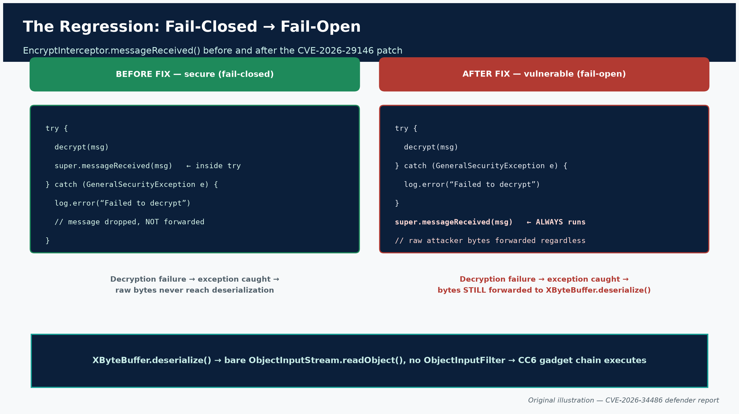
Figure 2. Before/after control flow inside EncryptInterceptor.messageReceived(). Original illustration — CVE-2026-34486 defender report.
This is a textbook "fail open" instead of "fail closed" defect (CWE-311, Missing Encryption of Sensitive Data; NVD also tags CWE-807, Reliance on Untrusted Inputs in a Security Decision). The forwarded bytes reach XByteBuffer.deserialize(), which constructs a bare ObjectInputStream without any ObjectInputFilter class-allow-listing and calls readObject() on attacker-controlled data (SocRadar; striga.ai). In other words, the encryption layer that was supposed to gate access to this deserialization sink can simply be skipped by sending a message that fails to decrypt, rather than one that decrypts successfully.
Apache's own advisory text states this concisely: "An error in the fix for CVE-2026-29146 allowed the EncryptInterceptor to be bypassed" (tomcat.apache.org/security-11.html).

3.4 End-to-end exploitation path
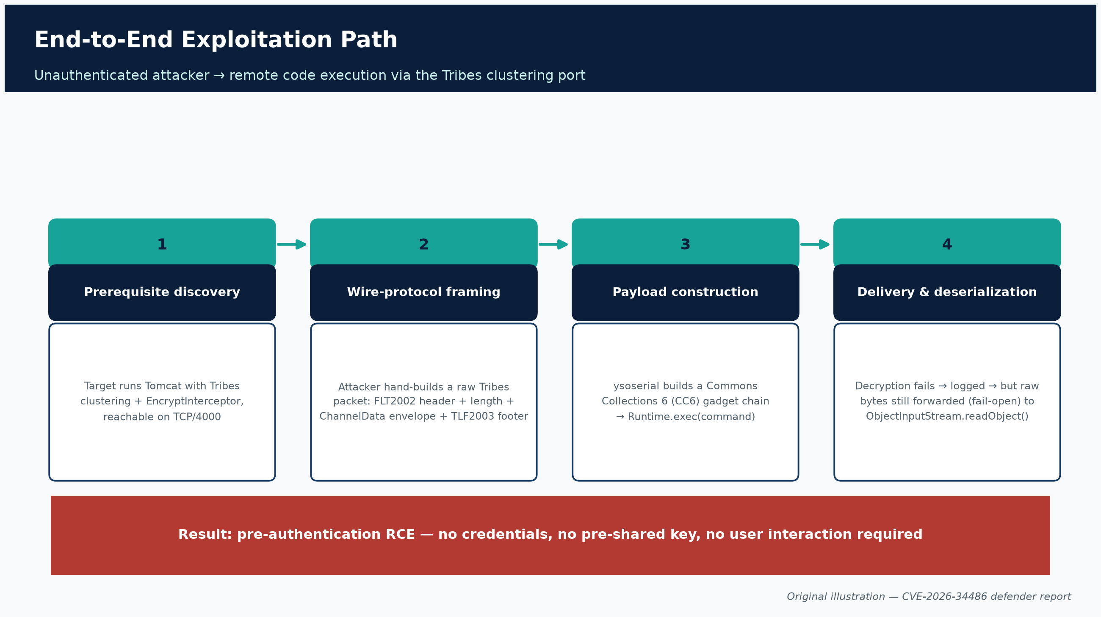
Figure 3. End-to-end exploitation path from prerequisite discovery to RCE. Original illustration — CVE-2026-34486 defender report.
- Prerequisite discovery. The target must be running Tomcat with Tribes clustering enabled and EncryptInterceptor configured, with the cluster receiver reachable from the attacker's network position — commonly TCP port 4000 (the default NioReceiver port), though this is configurable (striga.ai; Field Effect).
- Wire-protocol framing. The attacker constructs a raw Tribes packet by hand: a fixed FLT2002 header (7 bytes), a 4-byte length field, a ChannelData envelope containing a synthetic cluster-member address, the malicious serialized payload, and a TLF2003 footer (7 bytes) — no valid encryption or pre-shared key is required (striga.ai).
- Payload construction. The payload is a serialized Java object built with the open-source ysoserial tool using the Commons Collections 6 (CC6) gadget chain — chosen because it survives the JDK 8u72+ mitigations that broke earlier chains. The published PoC (404-src/CVE-2026-34486) documents the gadget mechanics: a HashSet.readObject() entry point triggers hashCode() computation on a TiedMapEntry, which delegates into a LazyMap, whose get() invokes a ChainedTransformer that ultimately reaches Runtime.getRuntime().exec(command).
- Delivery and deserialization. The crafted, unencrypted packet is sent directly to the Tribes receiver port. EncryptInterceptor.messageReceived() attempts to decrypt it, throws IllegalBlockSizeException/GeneralSecurityException, logs the failure — and then, due to the regression, still calls super.messageReceived(msg) with the raw bytes, which flow to XByteBuffer.deserialize() and ObjectInputStream.readObject(), executing the gadget chain's shell command as the Tomcat process user (striga.ai; SocRadar).
The net effect: an unauthenticated, network-reachable attacker who can reach the Tribes port gets pre-authentication remote code execution, without needing the pre-shared cluster encryption key, without user interaction, and without any credentials — a striking outcome from a vulnerability nominally classified as a confidentiality-only "missing encryption" bug.

3.5 Why the CVSS scoring is contested
This gap between the formal CVE title ("missing encryption of sensitive data") and the practical RCE outcome is reflected in genuinely divergent severity scores across sources, which defenders should reconcile rather than pick one arbitrarily:
- NVD/CISA-ADP score: 9.8 CRITICAL (CVSS:3.1/AV:N/AC:L/PR:N/UI:N/S:U/C:H/I:H/A:H) — full compromise of confidentiality, integrity, and availability, consistent with the RCE-via-deserialization outcome (NVD).
- Red Hat's score: 7.5 HIGH (CVSS:3.1/AV:N/AC:L/PR:N/UI:N/S:U/C:H/I:N/A:N) — confidentiality-only impact, scoring strictly to the missing-encryption description rather than the downstream deserialization consequence (NVD; GHSA-69r9-qgr7-g2wj).
- Third-party Nuclei template severity: Critical, 9.8, matching the CISA-ADP score and reflecting the RCE-capable exploitation path the template implements (Nuclei template).
Defender takeaway: treat CVE-2026-34486 as a critical, unauthenticated RCE vector wherever Tribes clustering with EncryptInterceptor is enabled and reachable, regardless of which CVSS number a given vendor feed surfaces. The FIRST.org Exploit Prediction Scoring System rates it accordingly: an EPSS score of 0.8116 (81.16%), 99.6th percentile, as of August 5, 2026 — more likely to be exploited in the next 30 days than roughly 99.6% of all scored CVEs (FIRST.org EPSS API).

4. Affected and fixed version matrix

All version data below is drawn directly from the Apache Tomcat project's own per-branch security pages, cross-checked against the GitHub Security Advisory and NVD.
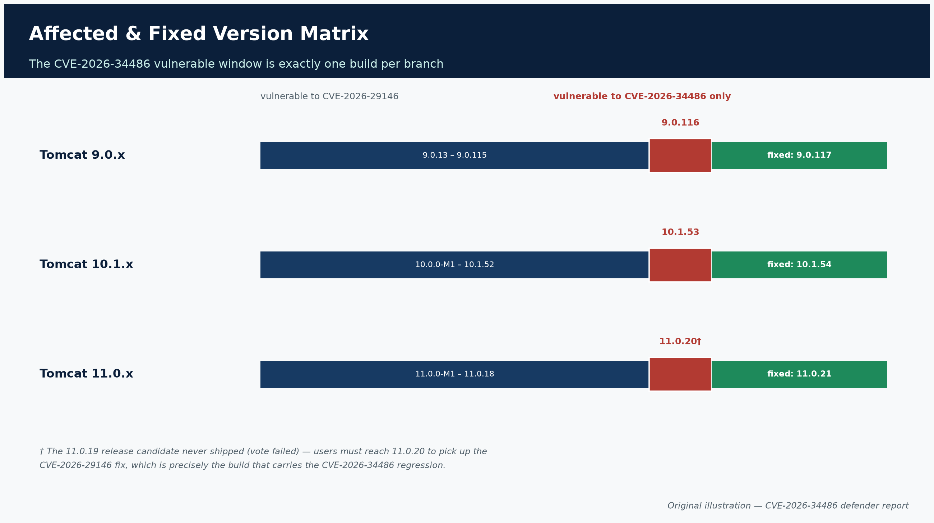
Figure 4. The CVE-2026-34486 vulnerable window is exactly one build per branch. Original illustration — CVE-2026-34486 defender report.

4.1 CVE-2026-29146 (EncryptInterceptor padding-oracle) — the original flaw
Branch | Affected versions | Fixed version | Source
Tomcat 11.0.x | 11.0.0-M1 – 11.0.18 | 11.0.19 / 11.0.20* | security-11.html
Tomcat 10.1.x | 10.0.0-M1 – 10.1.52 | 10.1.53 | security-10.html
Tomcat 9.0.x | 9.0.13 – 9.0.115 | 9.0.116 | security-9.html
Tomcat 8.5.x (EOL) | 8.5.38 – 8.5.100 | Not separately re-released | NVD CVE-2026-29146
Tomcat 7.0.x (EOL) | 7.0.100 – 7.0.109 | Not separately re-released | NVD CVE-2026-29146

* Apache's advisory notes an important nuance: the fix logically landed in what would have been 11.0.19, but that release candidate's vote did not pass, so 11.0.19 was never shipped. Consequently, users must download 11.0.20 to get a released version containing the CVE-2026-29146 fix — and 11.0.19 itself does not appear in Apache's affected-version list because it was never released. This quirk matters operationally: any inventory tool flagging "running < 11.0.19" as vulnerable and "≥ 11.0.19" as safe will misclassify 11.0.20 hosts as patched for CVE-2026-29146 while they remain exposed to CVE-2026-34486.
NVD lists the 7.x and 8.5.x lines as carrying the same underlying weakness pattern, but the Apache project's own per-branch advisories are authoritative for exact fixed builds; 7.x and 8.5.x had reached end-of-life status by the time of disclosure and organizations still running them should treat the entire line as unsupported and unpatched by definition (NVD CVE-2026-29146).

4.2 CVE-2026-34486 (EncryptInterceptor bypass regression) — the actively exploited flaw
Branch | Affected version(s) | Fixed version | Source
Tomcat 11.0.x | 11.0.20 only | 11.0.21 | security-11.html
Tomcat 10.1.x | 10.1.53 only | 10.1.54 | security-10.html
Tomcat 9.0.x | 9.0.116 only | 9.0.117 | security-9.html

Because CVE-2026-34486 is a regression introduced by the CVE-2026-29146 fix itself, its affected-version window is narrow and precise: exactly the single patch release on each branch that shipped the flawed fix (11.0.20, 10.1.53, 9.0.116). All three fixes were released together on April 4, 2026 (GHSA-69r9-qgr7-g2wj), and both CVEs were publicly disclosed on April 9, 2026.
Practical scanning implication: a host running 11.0.20, 10.1.53, or 9.0.116 exactly is vulnerable to CVE-2026-34486 even though it is already patched against the original CVE-2026-29146 padding-oracle flaw. Conversely, a host on an older build (e.g., 11.0.18) is vulnerable to CVE-2026-29146 but not to CVE-2026-34486. Vulnerability-management teams should track both CVEs as distinct entries in asset inventories and confirm the exact patch level, not just "is EncryptInterceptor patched."

4.3 Downstream / repackaged distributions
- Red Hat Enterprise Linux 10 (and EUS/ELS variants, x86_64/s390x/ppc64le/aarch64): erratum RHSA-2026:36788 fixes both CVEs together, shipping package version tomcat-10.1.49-3.el10_2. This erratum also removes the Tomcat clustering JAR from RPM builds (bug RHEL-168577) — relevant to defenders (see §6).
- SUSE has published a security-vulnerabilities KB entry covering both CVEs; it requires an authenticated SUSE support portal session to view in full (SUSE KB, access-restricted).
Organizations running Tomcat via a Linux distribution, container base image, or commercial Java application-server bundle should confirm the packaged Tomcat version against their vendor's own advisory rather than assuming the upstream Apache version number applies unchanged.

4.4 Related but distinct April 2026 Tomcat CVEs
Apache's April 2026 security releases also addressed several other, unrelated Tomcat CVEs in the same release cycle (CVE-2026-34483, CVE-2026-34487, CVE-2026-34500 per vendor advisory indexing — Quest KB 4383150). These are not part of the EncryptInterceptor issue chain; defenders patching to 9.0.117/10.1.54/11.0.21 will receive fixes for all of them as a byproduct of the upgrade.

5. Evidence of exploitation and public exploit code

Defenders should distinguish four separate categories of evidence, each with a different evidentiary weight.

5.1 CISA's KEV catalog listing (authoritative confirmation of in-the-wild exploitation)
Field | Value
Vendor/project | Apache
Product | Tomcat
Vulnerability name | Apache Tomcat Missing Encryption of Sensitive Data Vulnerability
Date added | 2026-08-04
Due date | 2026-08-07
Required action | Apply vendor-supplied fixes per BOD 26-04 guidance, or discontinue use of the product if mitigations are unavailable

(Source: CISA KEV JSON feed; catalog UI filtered to this CVE: cisa.gov/known-exploited-vulnerabilities-catalog.)
CISA does not publish the underlying evidence it used to confirm exploitation (this is standard KEV practice), and the KEV entry text does not name Unit 42, DeepSeek, Hermes Agent, or any specific threat actor. The KEV listing is best read as: "CISA independently confirms this CVE is being exploited," full stop — a separate question from who is doing the exploiting, addressed next.

5.2 Unit 42's independent attribution research (named actor, AI tooling, specific behavior)
Palo Alto Networks' Unit 42 published a detailed technical report on July 30, 2026 — roughly a week before CISA's KEV addition — documenting a Chinese-speaking threat actor, operating under the aliases "knaithe" and "KnYuan", assessed to be based in Zhuhai, China, and self-described as maintaining "1DayNews," an automated vulnerability-intelligence pipeline aggregating RCE disclosures from 17 sources (Unit 42).
Unit 42 attributes exploitation attempts against CVE-2026-34486 specifically to this actor, characterizing them as manual (as opposed to autonomous-AI-driven) exploitation:
Apache Tomcat (CVE-2026-34486): manual active exploitation, reverse shell attempts against nine separate Apache Tomcat instances, via Java-deserialization-based reverse shells. Success status is described as partially unclear because the actor deleted batch-exploitation files from their own infrastructure. (Unit 42)
Researchers reached this attribution because the actor's own operational infrastructure was inadvertently exposed: Unit 42 reports that "Hermes Agent inadvertently started HTTP file server in home directory (/home/worker)," exposing the actor's AI tool configurations and API keys, exploit scripts and target lists, and bash history / autonomous session logs — the same self-inflicted OPSEC failure that let Unit 42 reconstruct the operator's full toolkit and targeting logic.
Corroborating quotes from Unit 42's Andy Piazza, senior director of threat intelligence, are reported by Infosecurity Magazine: AI capabilities "enabled them to dramatically increase the speed and scale of their campaigns," and "the technical barrier to AI-augmented offensive operations is low and continues to decrease."
What Unit 42 does not claim: that the AI agent itself autonomously exploited Apache Tomcat. Their own CVE-by-CVE breakdown explicitly labels the Tomcat activity "manual," in contrast to the Langflow (CVE-2026-33017) and n8n (CVE-2026-21858/CVE-2025-68613) targeting, which the AI agent conducted with substantial autonomy but which failed due to target-side configuration/authentication prerequisites (see §6).

5.3 Public proof-of-concept exploit code
Multiple independent, functional PoC exploits for CVE-2026-34486 are publicly available:
- striga-ai/CVE-2026-34486 — attributed to researcher Bartlomiej Dmitruk of striga.ai; includes a Docker-based reproduction harness (vulnerable Tomcat 11.0.20 image), a ysoserial CC6 payload generator, an automated run.sh script, and verification via a marker file (/tmp/pwned). Full writeup at striga.ai/research/tomcat-tribes-unauth-rce.
- 404-src/CVE-2026-34486 — a separate implementation (exp.py) supporting direct command execution, command execution with HTTP-based output retrieval, and an interactive reverse-shell mode.
- projectdiscovery/nuclei-templates — CVE-2026-34486.yaml — a community Nuclei detection template (author DhiyaneshDk) that crafts a serialized payload and confirms exploitation via out-of-band DNS interaction (Interactsh).
Field Effect's independent write-up on the public PoC notes that exploitation "removes the vulnerable code path" only via upgrade, and that restricting network access to the clustering port (commonly 4000) or disabling clustering altogether are the practical short-term levers (Field Effect).
Defender implication: with three independent, working exploitation toolchains publicly documented and an EPSS score in the 99.6th percentile, any internet-reachable, unpatched Tribes/EncryptInterceptor deployment should be assumed to be within reach of both opportunistic mass-scanning actors and targeted operators.

5.4 What remains unverified
- Whether the nine Tomcat reverse-shell attempts actually succeeded. Unit 42's own report flags this as "partially unclear" because the actor deleted the relevant batch-exploitation files. Treat this specific campaign's Tomcat outcome as attempted, not confirmed-successful.
- Whether the CISA KEV addition was triggered by the same activity Unit 42 observed, or separate telemetry. The near-simultaneous timing (Unit 42 report July 30, KEV addition August 4–5) is suggestive but not confirmed as causally linked in any primary source reviewed.
- Total scale of victimization. No primary source provides a victim count, sector breakdown, or geographic distribution specific to CVE-2026-34486 exploitation beyond Unit 42's "nine Apache Tomcat instances" figure for the one actor it tracked.

6. The AI-orchestrated campaign, in full

Because the framing of this incident centers on "AI orchestration," defenders should understand precisely what that meant in practice — it is more nuanced than "an AI autonomously hacked Tomcat."

6.1 Actor profile and tooling
Unit 42 profiles the actor as an "opportunistic exploit operator and self-described binary security researcher" who maintains a public vulnerability-intelligence aggregation project ("1DayNews") pulling RCE disclosures from 17 sources. The core AI stack:
- Hermes Agent — an open-source agentic AI framework providing terminal access, Telegram-based command-and-control, and a "skills" plugin system, used as the orchestration layer.
- DeepSeek — the large language model used as the reasoning engine for code generation, target triage, and vulnerability assessment within Hermes Agent.
- Custom offensive "skills" built on top, including a jailbreak-oriented module ("godmode"), a web-terminal-exploitation module, and an integration with the FofaMap-Platinum-Full-Expert MCP server for internet-wide asset enumeration (via the FOFA search engine) and automated Nuclei scan generation.
- Secondary/comparative AI usage: Chinese-market models Qwen, GLM, Kimi, and MiniMax were tested; Western tools Claude Code and OpenAI Codex were used only in limited capacity, routed through a proxy (code.newcli[.]com) to reduce traceability, while direct API access was retained for DeepSeek and Qwen endpoints.

6.2 What the AI agent actually did autonomously — and where it failed
Unit 42 reconstructed a full autonomous session from May 7, 2026 logs ("Figure 1: Autonomous attack flow"), which illustrates both the capability and its current limits:
- Langflow (CVE-2026-33017, CVSS 9.8): DeepSeek downloaded a public PoC from GitHub, used FOFA to enumerate 84 internet-exposed Langflow instances, and identified one running a vulnerable version (1.3.4) — but exploitation failed because the target lacked a prerequisite workflow configuration.
- Autonomous pivot: after the Langflow failure, the agent independently surveyed ten other product families via FOFA and searched GitHub for trending 2026 CVE PoCs ranked by star count, reasoning in its own logged output that an n8n vulnerability with "258 stars and CVSS 10.0 looks extremely promising."
- n8n (CVE-2026-21858 / CVE-2025-68613): FOFA identified 647,017 global n8n instances (25,209 in China); the agent scanned 50+ Chinese instances, confirmed three vulnerable versions — but all required authentication the actor did not have, so autonomous exploitation again failed and the session ended without compromise.
Unit 42's overall assessment: the autonomous AI-driven attack cycle compressed what would be hundreds of hours of manual reconnaissance and triage into minutes, but it did not, in the sessions researchers recovered, achieve a fully autonomous successful compromise — every confirmed successful or attempted intrusion in the campaign (Tomcat, Citrix NetScaler, Marimo Notebook, Windows IKE VPN) was carried out through manual exploitation by the human operator, using conventional tradecraft, after AI-assisted targeting narrowed the field.

6.3 Full campaign scorecard (as reported by Unit 42)
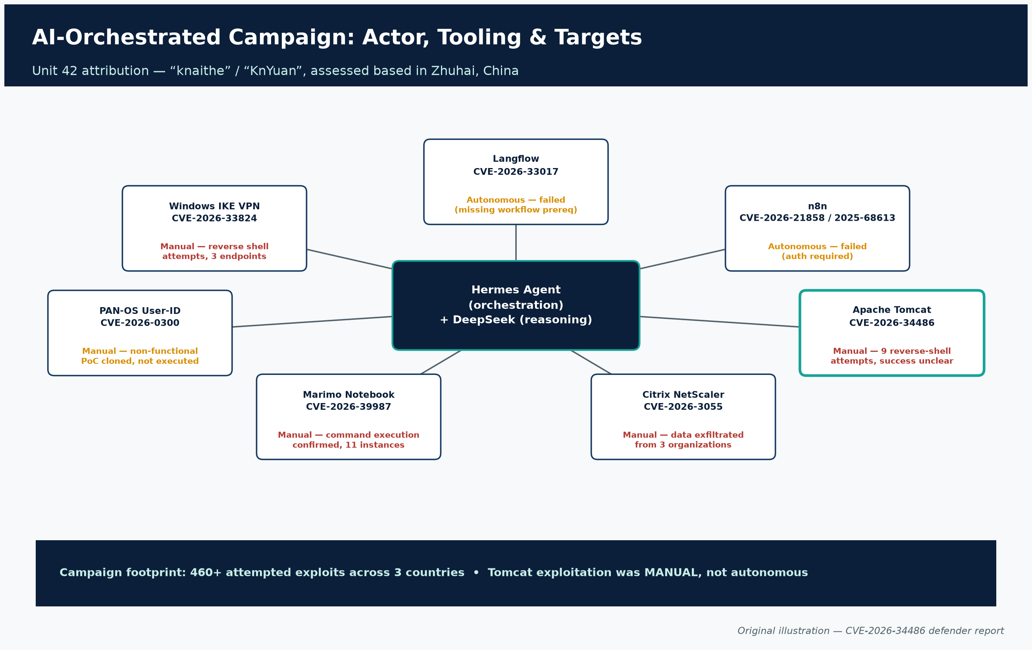
Figure 5. Actor tooling (Hermes Agent + DeepSeek) and the seven CVEs targeted in the campaign, with method and outcome. Original illustration — CVE-2026-34486 defender report.
CVE | Product | CVSS | Method | Outcome
CVE-2026-33017 | Langflow | 9.8 | Autonomous (AI-driven) | Failed — missing workflow prerequisite
CVE-2026-21858 / 2025-68613 | n8n | 10.0 / 9.9 | Autonomous (AI-driven) | Failed — authentication required
CVE-2026-34486 | Apache Tomcat | 7.5 | Manual | Active exploitation attempted; reverse shells against 9 targets; success unclear (evidence deleted)
CVE-2026-3055 | Citrix NetScaler ADC | 9.8 | Manual | Data exfiltrated from 3 organizations; NSC_AAAC session-cookie theft observed
CVE-2026-39987 | Marimo Notebook | 9.8 | Manual | Command execution confirmed, 11 instances
CVE-2026-0300 | PAN-OS User-ID Portal | 9.8 | Manual | Non-functional PoC cloned, not executed
CVE-2026-33824 | Windows IKE VPN extensions | 9.8 | Manual | Reverse shell attempts against 3 VPN endpoints

Unit 42 also reports the campaign's overall footprint as 460+ attempted exploits across three countries, with sustained multi-day targeting of a Malaysian government entity behind proxy anonymization, and evidence of intent to hijack Citrix sessions by searching memory dumps for NSC_AAAC authentication cookies.

6.4 A note on CVE numbering: two different "Langflow" CVEs
Readers should not conflate CVE-2026-33017 (the Langflow CVE the AI agent unsuccessfully attempted in Unit 42's campaign) with CVE-2026-9198 (the different Langflow remote-code-execution CVE that CISA added to its KEV catalog on the same day as CVE-2026-34486, described as chaining two API endpoints to achieve unauthenticated superuser RCE on default deployments — thehackernews.com). These are separate CVE identifiers describing separate Langflow flaws; the only connection is that both happened to be discussed in the same week of coverage.

7. Detection guidance

7.1 Log signatures
The single highest-value log signature is Tomcat's own decryption-failure error, which fires immediately before the vulnerable fail-open code path executes. Multiple independent technical analyses converge on the same log line format:
SEVERE [Tribes-Task-Receiver-...] org.apache.catalina.tribes.group.interceptors.EncryptInterceptor.messageReceived
Failed to decrypt message javax.crypto.IllegalBlockSizeException

Operational guidance for hunting on this signature:
- A single such log entry is not necessarily malicious — legitimate cluster nodes can occasionally produce decryption errors from network corruption, misconfiguration, or key mismatches during rolling upgrades.
- Repeated "Failed to decrypt message" entries from unrecognized IP addresses are a strong indicator of active probing or exploitation attempts, since a real attacker sending crafted packets will trigger this exact exception on every attempt.
- Critically, a successful exploitation attempt may leave no deserialization exception in the logs — once the CC6 gadget chain executes, command execution occurs silently; the only log trace is often the decryption-failure line itself. Defenders should not wait for a "deserialization error" signature that may never appear.
- Cross-reference the asymmetric fail-open (receive) vs. fail-closed (send) behavior: outbound cluster messages that fail to encrypt are correctly blocked, so a defender who sees encryption failures only on the receive side, disproportionately from one source, should treat that source as suspect.

7.2 Network indicators
- Unsolicited or unauthenticated TCP traffic to the Tribes clustering port — default TCP/4000 (NioReceiver), though deployments may reconfigure this. Any connection from outside the known, static set of cluster-member IPs is anomalous by definition.
- Internet-facing exposure of the Tribes port at all is itself the primary risk indicator — this component was never intended to be reachable from the public internet.
- Malformed or oversized Tribes protocol frames — the exploit payload framing (FLT2002 header / length field / ChannelData envelope / serialized payload / TLF2003 footer) does not match legitimate encrypted cluster traffic patterns and can be fingerprinted by monitoring tooling that can parse the Tribes wire format.
- Outbound reverse-shell or callback connections originating from the Tomcat process shortly after inbound traffic to the Tribes port — consistent with the Java-deserialization-based reverse shells Unit 42 observed.

7.3 Published detection tooling
- Nuclei template: http/cves/2026/CVE-2026-34486.yaml (author DhiyaneshDk, severity Critical/9.8) — sends a crafted serialized payload to the Tribes port and confirms via out-of-band DNS interaction. Intended for authorized scanning; assume adversaries are also running it at scale.
- Palo Alto Networks Advanced Threat Prevention signatures, referenced by Unit 42 in connection with the broader campaign: signature IDs 97030, 96882, 96855, 97044, 97046, 97251, 97177, 510019.
- Cortex Xpanse is cited by Unit 42 as capable of identifying exposed Langflow, n8n, and Citrix ADC/NetScaler devices — this citation covers the other CVEs more directly than Tomcat/Tribes; verify current Xpanse coverage for Tribes-port exposure specifically with the vendor.
- No dedicated Snort or Suricata community rule specific to CVE-2026-34486 was located as a confirmed, published rule at the time of this research; build custom detection around the Tribes wire-protocol markers (§7.2) or consult your IDS vendor's latest signature set.

7.4 Asset discovery and exposure verification
- Inventory every Tomcat instance (standalone, embedded, containerized, cloud-managed) and record its exact version string.
- Determine whether Tribes clustering is enabled (<Cluster> element present and active in server.xml / context.xml), and specifically whether EncryptInterceptor is configured within the cluster channel's interceptor chain.
- Determine network reachability of the clustering port from outside the trusted cluster-node set — including other internal network segments, not just the public internet.
- Cross-reference exact version against §4's matrix — remember that 9.0.116 / 10.1.53 / 11.0.20 are vulnerable to CVE-2026-34486 specifically, even though they already contain the CVE-2026-29146 fix.

8. Interim mitigations for teams that cannot patch immediately

The authoritative, permanent fix is upgrading to Tomcat 9.0.117, 10.1.54, or 11.0.21 (or later) — this is the only action that removes the vulnerable code path entirely. Where an immediate upgrade is not operationally possible, the following compensating controls should be layered, not treated as substitutes for patching.
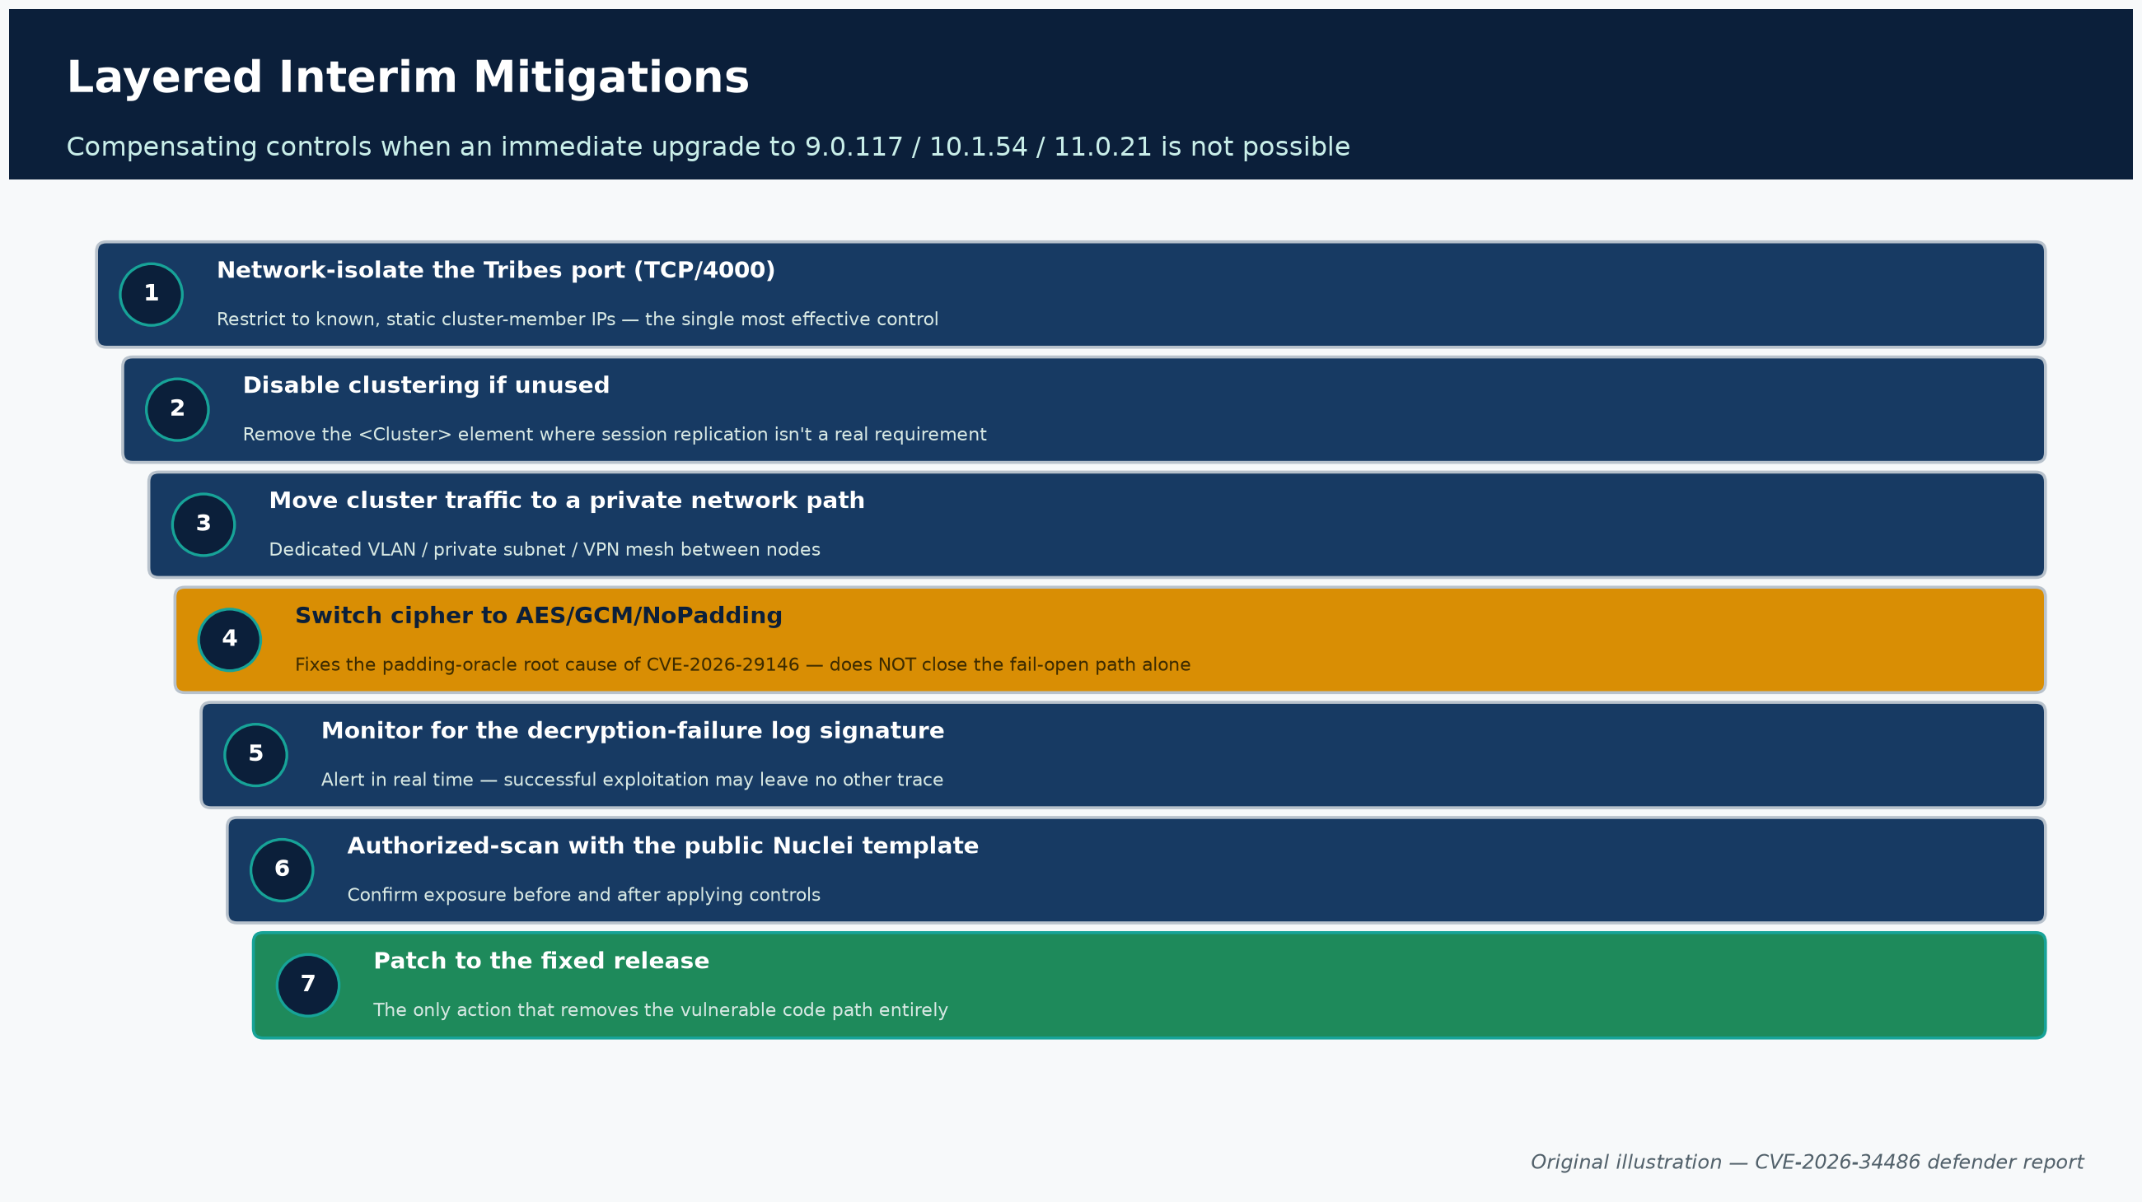
Figure 6. Layered interim mitigations, from network isolation to patching. Original illustration — CVE-2026-34486 defender report.
- Network-isolate the Tribes clustering port. Restrict TCP/4000 (or whatever port the deployment's NioReceiver is configured to use) so it is reachable only from the known, static IP addresses of legitimate cluster member nodes. This is the single most effective compensating control.
- Disable clustering entirely if it is not actually in use. Many Tomcat deployments enable the <Cluster> element by default configuration inheritance without actually requiring session replication.
- Move cluster traffic onto a private, dedicated network path (isolated VLAN, private cloud subnet, or VPN mesh between nodes) rather than relying on EncryptInterceptor alone as a security boundary over shared or untrusted networks.
- If clustering must remain both enabled and reachable across a semi-trusted network, switch the encryption mode from the default AES/CBC/PKCS5Padding to the authenticated-encryption mode AES/GCM/NoPadding. Note, however, that this mitigates the padding-oracle weakness (CVE-2026-29146) but does not by itself fix the fail-open regression (CVE-2026-34486), since the vulnerable code path forwards any message that fails to decrypt, regardless of cipher mode. Cipher-mode hardening is not a substitute for patching or network isolation against CVE-2026-34486 specifically.
- Increase logging verbosity and actively monitor for the EncryptInterceptor.messageReceived — "Failed to decrypt message" signature (§7.1) from any source outside the expected cluster-member set, and alert on it in real time.
- Deploy the published Nuclei template against your own external and internal IP ranges under authorized scanning procedures to positively confirm exposure before and after applying compensating controls.
- If upgrade is fully blocked and network isolation cannot be guaranteed, CISA's own required action for KEV entries where a vendor mitigation cannot be applied is explicit: discontinue use of the affected product until remediation is possible — for internet-facing Tomcat clusters with EncryptInterceptor enabled and unpatched, this is CISA's stated baseline expectation for federal agencies, and a reasonable bar for any risk-conscious enterprise.

9. Regulatory and compliance context: CISA KEV and BOD 26-04

For U.S. federal civilian executive branch (FCEB) agencies, and as a de facto industry benchmark for many other organizations, CVE-2026-34486's KEV listing triggers obligations under BOD 26-04, "Prioritizing Security Updates Based on Risk," issued June 10, 2026, which supersedes and revokes the prior BOD 19-02 and BOD 22-01 frameworks.
BOD 26-04 moves away from a flat "patch every KEV entry within a fixed window" model toward a risk-tiered framework built on four variables:
- Whether the affected asset is publicly/internet exposed.
- Whether the vulnerability is listed in the KEV catalog.
- Whether exploitation can be automated by an adversary.
- The technical impact an attacker achieves upon successful exploitation.
Vulnerabilities meeting all four high-risk conditions — internet-exposed, KEV-listed, automatable, and high-impact — fall into the most urgent tier, requiring remediation within three calendar days, coupled with a mandatory forensic triage of the affected asset to determine whether it may already have been compromised. Lower-risk combinations receive longer windows, and the lowest-risk vulnerabilities can be deferred to the next scheduled system upgrade.
CVE-2026-34486 plausibly sits in or near this highest-urgency tier for any agency running an internet-reachable, unpatched Tribes/EncryptInterceptor deployment: it is KEV-listed, its exploitation is scriptable/automatable (as demonstrated by three independent public PoC toolchains and a Nuclei template), and its technical impact is unauthenticated remote code execution. CISA's own KEV entry set the August 7, 2026 due date and explicitly frames required action around BOD 26-04 guidance. Note that some secondary press coverage of this KEV addition still cites the deadline as flowing from "BOD 22-01" (SecurityAffairs) — this appears to be outdated terminology carried over from before the June 2026 transition; BOD 26-04 is the directive of record as of this writing per CISA's own directive page.
Non-federal organizations are not bound by BOD 26-04, but CISA and most vulnerability-management frameworks recommend treating KEV membership as a strong prioritization signal regardless of sector, particularly given the concrete, named threat-actor activity documented against this specific CVE.

10. Open questions and limitations of current evidence

Defenders and analysts should treat the following as genuinely unresolved, based on the primary sources reviewed for this report:
- Did the nine attempted Tomcat compromises in Unit 42's tracked campaign actually succeed? Unit 42 itself states this is "partially unclear" due to the actor's deletion of batch-exploitation evidence. No primary source confirms a successful, verified compromise attributable to this specific actor via CVE-2026-34486.
- Is CISA's KEV addition evidentially linked to the Unit 42-tracked actor, or to separate/additional exploitation activity CISA observed independently? No primary source establishes a direct causal or evidentiary link between the two. CVE-2026-34486 is also exploitable via three independently published, generic PoCs that any actor, AI-assisted or not, could use.
- How much of the broader "AI-orchestrated" narrative generalizes beyond this one actor? The Tomcat exploitation within this campaign was manual, not autonomous — the "AI orchestration" framing applies most directly to the actor's reconnaissance and target-selection workflow, not to the Tomcat exploitation mechanics themselves.
- Full scale and victimology of CVE-2026-34486 exploitation industry-wide. No primary source reviewed provides an aggregate victim count, sector distribution, or geographic spread specific to this CVE beyond the "nine Tomcat instances" figure tied to one tracked actor.
- Whether GCM-mode reconfiguration alone (without patching) meaningfully reduces real-world risk for CVE-2026-34486. Cipher-mode hardening addresses the padding-oracle root cause of CVE-2026-29146 but does not close the fail-open code path that defines CVE-2026-34486; this report's assessment on that point is inference from the documented code defect (§3.3), not a directly cited test result.
- Exact patch level of the SUSE advisory. The SUSE KB article covering both CVEs sits behind an authenticated support portal and could not be independently verified beyond its existence and title.
- No dedicated public Snort/Suricata signature was confirmed to exist for this CVE at time of writing (§7.3) — a gap in the current public detection-engineering ecosystem, not a claim that no such signature will ever exist.

Sources

# | Source | Link
1 | Apache Tomcat Security page (v11) | https://tomcat.apache.org/security-11.html
2 | Apache Tomcat Security page (v10) | https://tomcat.apache.org/security-10.html
3 | Apache Tomcat Security page (v9) | https://tomcat.apache.org/security-9.html
4 | NVD CVE-2026-34486 | https://nvd.nist.gov/vuln/detail/CVE-2026-34486
5 | NVD CVE-2026-29146 | https://nvd.nist.gov/vuln/detail/CVE-2026-29146
6 | GHSA-69r9-qgr7-g2wj | https://github.com/advisories/GHSA-69r9-qgr7-g2wj
7 | CISA KEV JSON feed | https://www.cisa.gov/sites/default/files/feeds/known_exploited_vulnerabilities.json
8 | CISA KEV Catalog (filtered) | https://www.cisa.gov/known-exploited-vulnerabilities-catalog?field_cve=CVE-2026-34486
9 | CISA Alert, Aug 4 2026 | https://www.cisa.gov/news-events/alerts/2026/08/04/cisa-adds-three-known-exploited-vulnerabilities-catalog
10 | CISA BOD 26-04 | https://www.cisa.gov/news-events/directives/bod-26-04-prioritizing-security-updates-based-risk
11 | Nucleus Security blog on BOD 26-04 | https://nucleussec.com/blog/navigating-requirements-cisa-bod-26-04/
12 | Unit 42, "Chinese-Speaking Threat Actor Harnesses AI Models for Autonomous Cyberattacks" | https://unit42.paloaltonetworks.com/autonomous-ai-cyber-attack-campaign/
13 | Oligo Security blog | https://www.oligo.security/blog/critical-apache-tomcat-flaw-allows-full-server-and-application-takeover-cve-2026-29146
14 | SocRadar blog | https://socradar.io/blog/cve-2026-34486-apache-tomcat-tribes-rce/
15 | Field Effect blog | https://fieldeffect.com/blog/public-exploit-code-apache-tomcat-flaw
16 | striga.ai technical research | https://striga.ai/research/tomcat-tribes-unauth-rce
17 | GitHub — striga-ai/CVE-2026-34486 | https://github.com/striga-ai/CVE-2026-34486
18 | GitHub — 404-src/CVE-2026-34486 | https://github.com/404-src/CVE-2026-34486
19 | nuclei-templates CVE-2026-34486.yaml | https://github.com/projectdiscovery/nuclei-templates/blob/main/http/cves/2026/CVE-2026-34486.yaml
20 | FIRST.org EPSS API | https://api.first.org/data/v1/epss?cve=CVE-2026-34486
21 | Red Hat RHSA-2026:36788 | https://access.redhat.com/errata/RHSA-2026:36788
22 | The Hacker News | https://thehackernews.com/2026/08/cisa-flags-langflow-rce-tomcat-and-n.html
23 | BleepingComputer | https://www.bleepingcomputer.com/news/security/cisa-warns-of-hackers-exploiting-langflow-n-central-apache-tomcat-flaws/
24 | SecurityAffairs | https://securityaffairs.com/196667/hacking/u-s-cisa-adds-langflow-apache-tomcat-and-n-able-n-central-flaws-to-its-known-exploited-vulnerabilities-catalog.html
25 | Cybersecurity News | https://cybersecuritynews.com/apache-tomcat-encryption-vulnerability/
26 | Infosecurity Magazine | https://www.infosecurity-magazine.com/news/chinese-hacker-deepseek-ai/
27 | Help Net Security | https://www.helpnetsecurity.com/2026/08/03/deepseek-ai-autonomous-cyberattacks-hermes-agent/
28 | Quest Support KB 4383150 | https://support.quest.com/kb/4383150/apache-tomcat-vulnerabilities-cve-2026-34483-cve-2026-34486-cve-2026-34487-and-cve-2026-34500

Explore more questions at Ask Anything

