DEFENDER'S GUIDE — CONTESTED DISCLOSURE
ShieldBreak: A Defender's Guide to the Claimed Microsoft Defender SYSTEM-Privilege Patch Bypass
CVE-2026-50656 — Status as of August 16, 2026
This is a fast-moving, contested disclosure. Every “claimed” and “reported” qualifier in this report is deliberate — Microsoft has not confirmed the bypass, no independent, methodologically transparent reproduction has been published, and no CISA KEV entry exists as of this writing. Re-check the MSRC advisory and the CISA KEV catalog directly before acting on any status claim here.

Contents

• Executive summary
• What's confirmed vs. what's claimed
• Background: RoguePlanet (CVE-2026-50656)
• ShieldBreak: the claimed patch bypass
• Is it really a bypass? Independent researcher disagreement
• Affected and fixed version matrix
• Is ShieldBreak being exploited in the wild?
• Detection guidance
• Interim mitigations and hardening
• The researcher, the disclosure fight, and why it matters
• Open questions
• Practical checklist for defenders
• Visual assets and credits
• Sources

Executive summary

"ShieldBreak" is the name given by a researcher operating under the handles Nightmare Eclipse / Chaotic Eclipse (GitHub: MSNightmare) to a proof-of-concept (PoC) published on August 11–12, 2026 — the day of Microsoft’s August 2026 Patch Tuesday — that the researcher claims fully defeats Microsoft’s July 2026 fix for CVE-2026-50656, an elevation-of-privilege vulnerability in the Microsoft Malware Protection Engine (mpengine.dll) publicly nicknamed RoguePlanet (The Hacker News; GitHub, MSNightmare/ShieldBreak). The claim: a local, low-privileged attacker who already has code execution on a fully patched Windows 11 25H2 or Windows Server 2025 host can reach NT AUTHORITY\SYSTEM by abusing how Windows Defender’s cloud-hydration file scanning interacts with the Cloud Files API and the Common Log File System (CLFS), with a reported 100% success rate on tested machines (BleepingComputer; SecurityAffairs).
Two points matter most for defenders triaging this today:
- The "bypass" framing is disputed by the two independent researchers who have actually tested it. Will Dormann, who reproduced the PoC and published a step-by-step technical breakdown, and Kevin Beaumont, a former Microsoft engineer who also confirmed the exploit functions on an up-to-date Windows 11 system, both describe ShieldBreak’s mechanism as architecturally distinct from RoguePlanet’s original race condition. Dormann wrote plainly that his "naive eyeballs fail to see the similarity" between the two (infosec.exchange, Dormann; SecurityWeek). If ShieldBreak is a separate bug in the Cloud Filter API integration rather than a true re-exploitation of CVE-2026-50656’s root cause, "no fix exists" is technically accurate but the vulnerability class, CVE assignment, and remediation path may all differ from what the "patch bypass" headline implies.
- No independent, on-the-record confirmation of in-the-wild exploitation exists, and CVE-2026-50656 does not appear in CISA’s KEV catalog as of this writing (CISA KEV catalog). Microsoft’s public statement is that it is "actively investigating the validity and potential applicability of these claims" (BleepingComputer). Treat this as a credible, independently-reproduced local-privilege-escalation PoC with no vendor fix, not a confirmed active-exploitation emergency — while still acting with urgency given the low bar to weaponize a working local-EoP PoC once it is public.
This report covers what is independently verifiable about the underlying weakness, the full version and patch history, the state of in-the-wild exploitation evidence, concrete detection content published by named researchers and vendors, and interim hardening for organizations that cannot rely on a patch that does not yet exist.
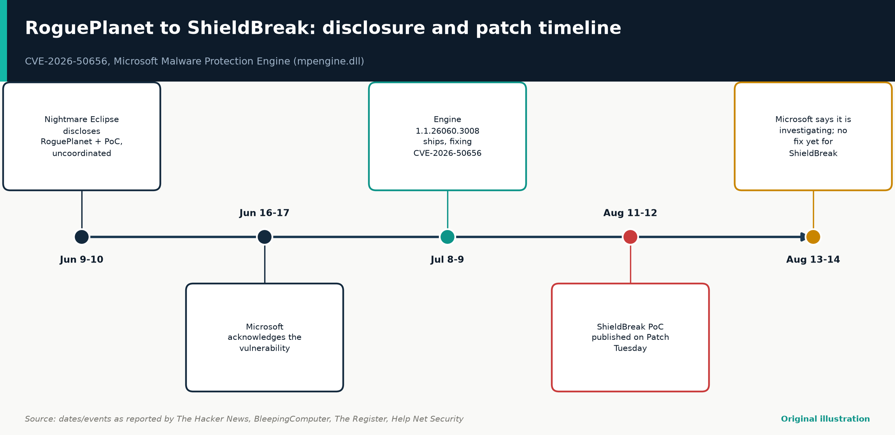
Figure 1. RoguePlanet's disclosure led to a July fix; ShieldBreak's PoC, published the following Patch Tuesday, claims to defeat that same fix.
Original illustration — compiled from The Hacker News, BleepingComputer, The Register, Help Net Security

What's confirmed vs. what's claimed

Claim | Status | Evidence
CVE-2026-50656 (“RoguePlanet”) is a real, Microsoft-confirmed elevation-of-privilege bug | Confirmed | Engine 1.1.26060.3008 shipped Jul 8–9, 2026
RoguePlanet was disclosed without coordination before a patch existed | Confirmed | PoC published Jun 9–10, 2026; Microsoft acknowledged days later
A working ShieldBreak PoC exists and is publicly downloadable | Confirmed | Public GitHub repository, MIT-licensed
ShieldBreak achieves SYSTEM on a fully patched, up-to-date Windows 11 host | Independently reproduced | Beaumont and Dormann separately confirmed functional escalation
ShieldBreak is “the same” RoguePlanet bug, merely bypassed | Disputed | Dormann and Beaumont both describe a materially different mechanism
Microsoft has confirmed the vulnerability and assigned a distinct CVE | Not yet | Microsoft says it is “investigating”; rides on CVE-2026-50656 for now
ShieldBreak is being actively exploited in the wild | Unconfirmed | No CISA KEV entry; no IR vendor report of live exploitation found
Windows 10 and older Server SKUs are vulnerable | Claimed, not independently validated | GitHub README states “vulnerable but not currently supported”

Background: RoguePlanet (CVE-2026-50656)

What it is
CVE-2026-50656 — publicly nicknamed RoguePlanet — is an elevation-of-privilege vulnerability in the Microsoft Malware Protection Engine (MMPE / mpengine.dll), the core scanning, detection, and remediation component shared across Microsoft Defender Antivirus, Microsoft Defender for Endpoint, and related Microsoft security products (The Hacker News; SentinelOne vulnerability database). Microsoft's own advisory language, as reported by outlets that reviewed it, classifies the flaw as a privilege-escalation issue reachable by an authenticated local user (The Hacker News).

Root cause
Multiple independent technical write-ups converge on the same underlying weakness class, even though they describe the specific exploitation primitive somewhat differently — a normal feature of early-stage analysis of an uncoordinated disclosure where no single vendor write-up is authoritative:
- CWE class: Reported as CWE-59, Improper Link Resolution Before File Access ("link following") (Kudelski Security; ThreatLocker). In plain terms: mpengine.dll runs as SYSTEM when it scans, quarantines, or remediates a file. If the engine does not re-verify a resolved path immediately before the privileged operation, an unprivileged local process can redirect that operation with a symbolic link, junction, or other reparse point.
- Timing class: a Time-of-Check-to-Time-of-Use (TOCTOU) race condition — the engine "checks" that a target file is safe, and the attacker wins a narrow timing window to substitute the target before the engine "uses" it (Cloud Security Alliance research note; Picus Security).
- Reported redirection primitives: NTFS reparse points/junctions (Picus Security) and, in a separate technical account, Volume Shadow Copy device creation timed against Defender’s remediation/quarantine workflow (Cloud Security Alliance).
- Why it happens architecturally: Defender’s remediation engine is, by design, one of the most highly privileged pieces of software on a Windows endpoint — it must delete, quarantine, or overwrite files anywhere on disk without prompting the user. As Morphisec’s analysis frames it, "when the tool you rely on to detect threats is itself the thing being exploited, detection has nothing left to detect with" (Morphisec).
A note on scoring inconsistency: most outlets report a CVSS base score of 7.8 for CVE-2026-50656 (The Hacker News; SecurityAffairs; Arctic Wolf), while SentinelOne’s vulnerability database lists a base score of 7.0 with vector CVSS:3.1/AV:L/AC:H/PR:L/UI:N/S:U/C:H/I:H/A:H (SentinelOne). Do not rely on any secondary aggregator’s score for risk-acceptance decisions — pull the live score from the MSRC Security Update Guide entry.

Disclosure and patch timeline
Date | Event
Jun 9–10, 2026 | Nightmare Eclipse publicly discloses RoguePlanet and publishes a PoC without prior coordination with Microsoft
Jun 16–17, 2026 | Microsoft acknowledges the vulnerability
Jul 8–9, 2026 | Microsoft ships a fix via a standalone Malware Protection Engine update (version 1.1.26060.3008)
Aug 11–12, 2026 | Same researcher publishes “ShieldBreak,” a PoC claimed to bypass the July fix, on August 2026 Patch Tuesday
Aug 13–14, 2026 | Microsoft issues a public statement that it is investigating; no fix has shipped for ShieldBreak

Microsoft's fix was delivered as a Malware Protection Engine update because MMPE, unlike OS-level components, updates independently of the Windows cumulative-update cycle — the engine can check for updates multiple times per day when a device is online (The Hacker News). This is operationally significant: “am I patched against RoguePlanet” is answered by the engine version, not the Windows OS build or the monthly cumulative KB.

ShieldBreak: the claimed patch bypass

What ShieldBreak claims to do
ShieldBreak is described by its author as demonstrating "a full patch bypass" of CVE-2026-50656 — i.e., that even on a system fully updated to Malware Protection Engine 1.1.26060.3008, a local attacker can still reach SYSTEM through Defender (GitHub, MSNightmare/ShieldBreak; SecurityAffairs). The researcher reports a 100% success rate on tested Windows 11 25H2 (including Canary channel) and Windows Server 2025 systems, and states — but has not demonstrated in the public PoC — that Windows 10 and corresponding Server editions are also vulnerable (The Hacker News; Cyberpress). Unlike RoguePlanet, ShieldBreak has not been assigned its own CVE identifier; press coverage ties it back to CVE-2026-50656 by association only, which is itself part of the technical dispute described below.

Technical mechanism as reported
The most detailed public technical account comes from independent vulnerability researcher Will Dormann, who reproduced the exploit and published a step-by-step description of its behavior on infosec.exchange (infosec.exchange, Dormann; relayed by SecurityWeek). At a conceptual level — without reproducing exact commands, code, or parameters — the reported chain is summarized in Figure 2.
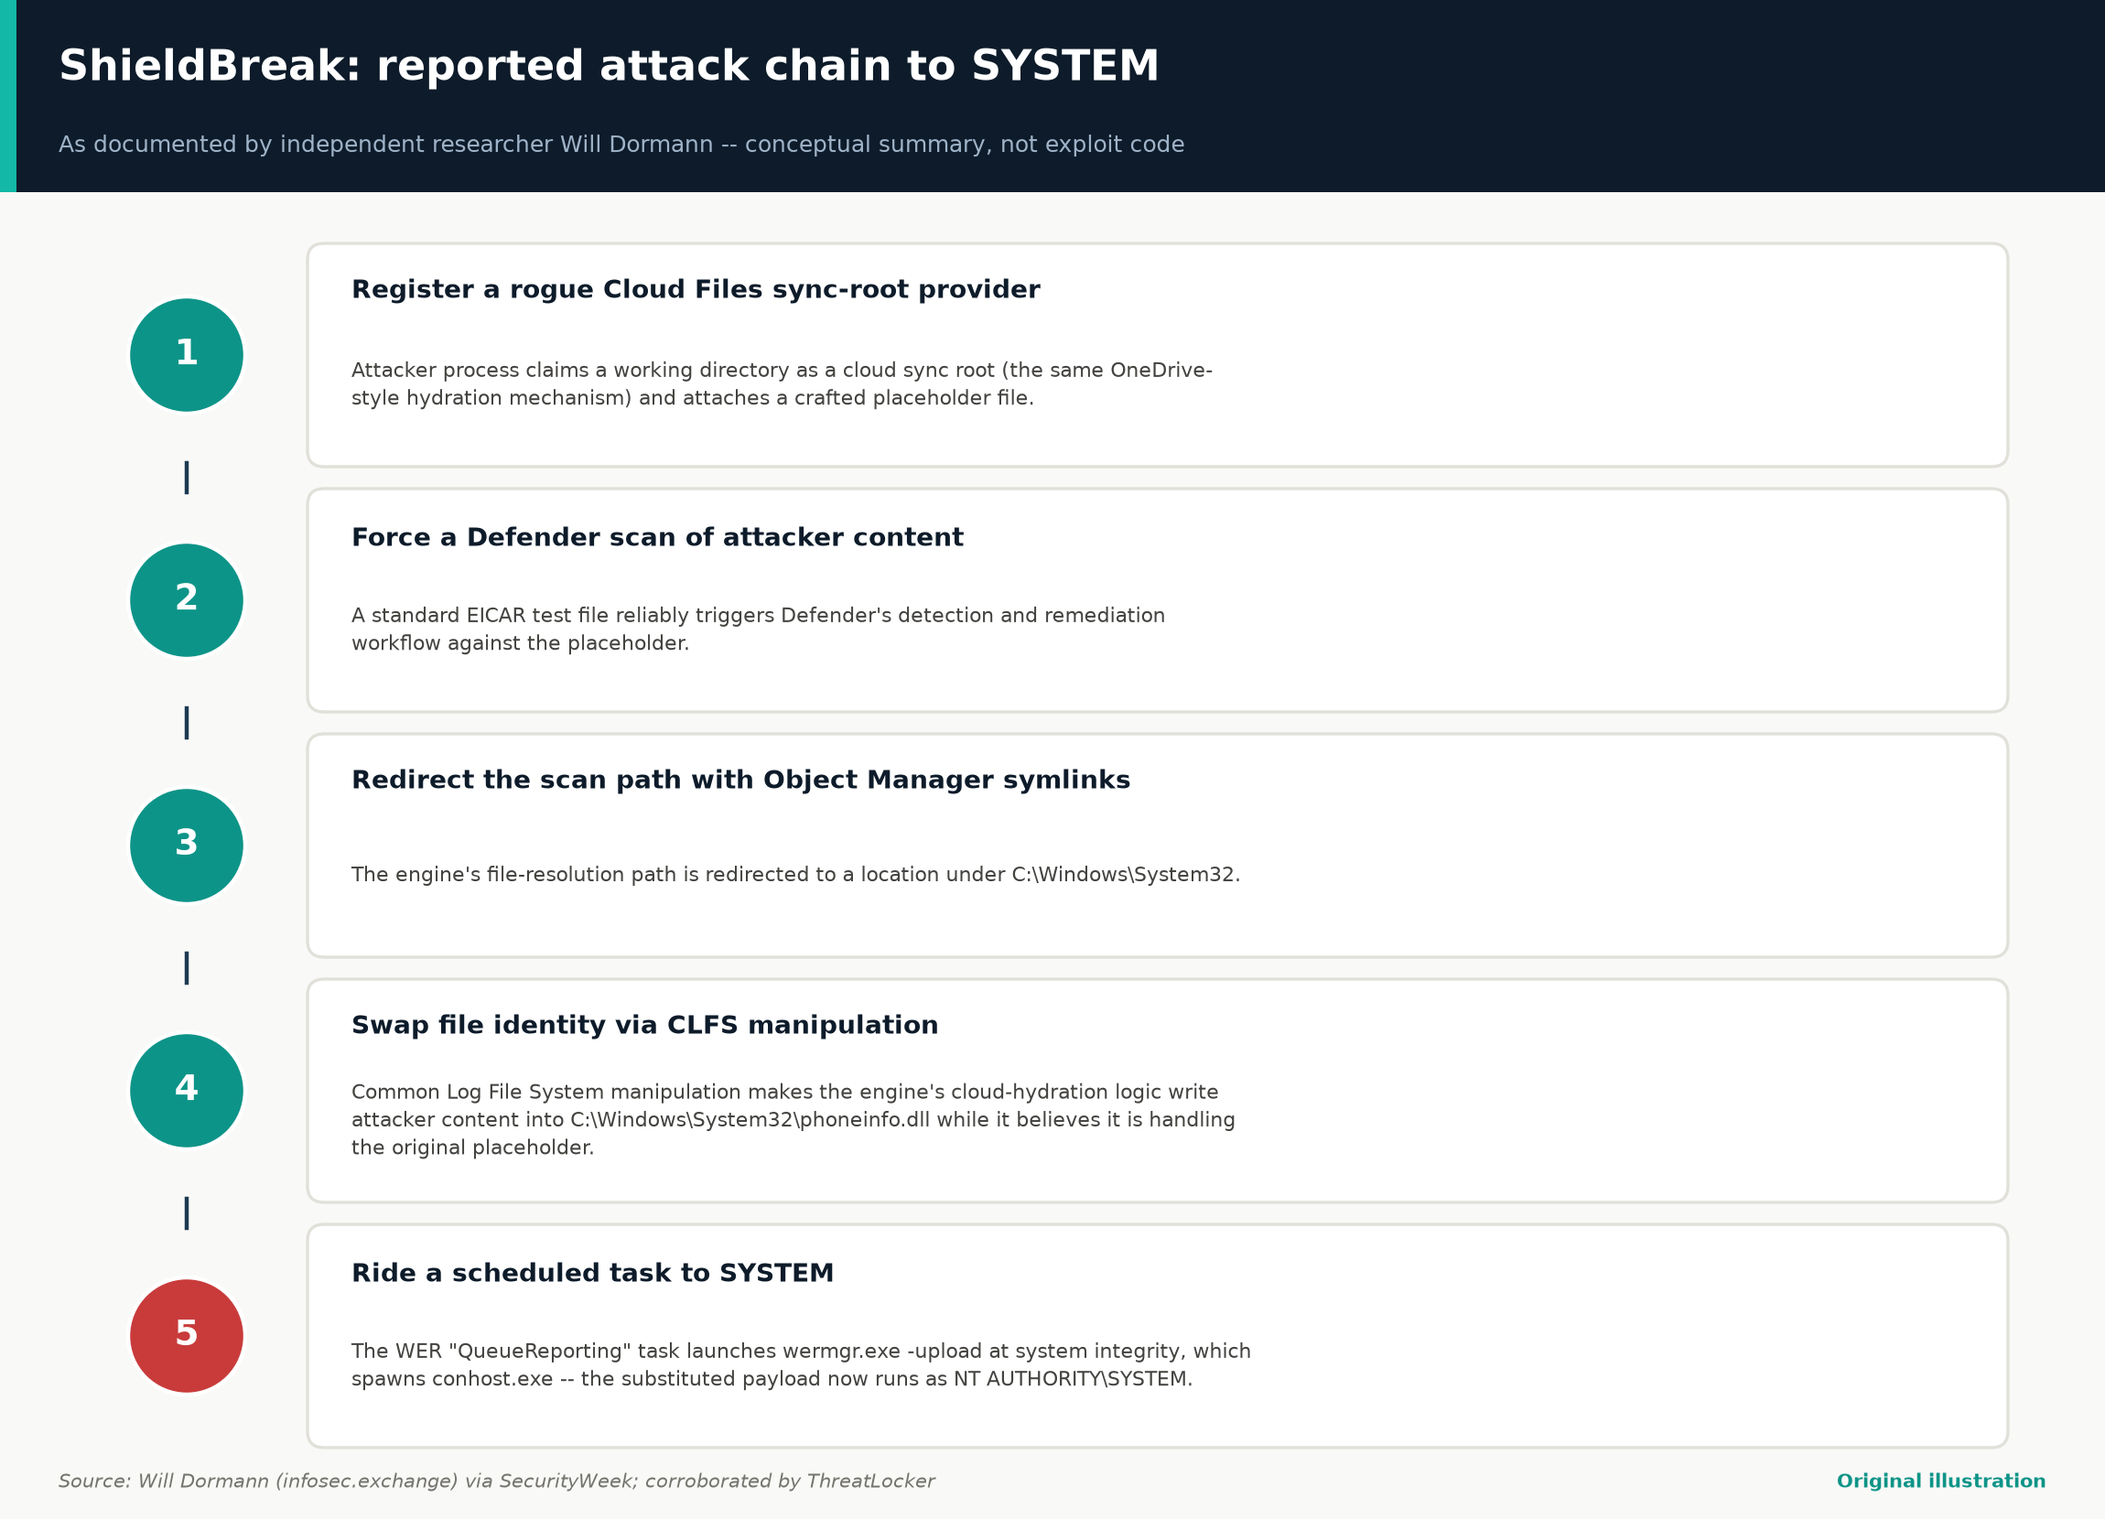
Figure 2. The five-step chain Will Dormann reported — from registering a rogue cloud sync provider to a SYSTEM-integrity shell via Windows Error Reporting.
Original illustration — based on Will Dormann (infosec.exchange) via SecurityWeek; corroborated by ThreatLocker
Kevin Beaumont, who independently confirmed the PoC’s effectiveness, summarizes the mechanism at a higher level as a "user-mode callback hook to change file contents during a Defender cloud-hydration scan via cfapi (Cloud Filter API)" (Beaumont, via BleepingComputer). ThreatLocker’s independent write-up broadly aligns with this account, describing the exploit as registering a Cloud Files sync root, using placeholder-file hydration, and injecting a payload — which it names Warden.dll in the public PoC’s build — that duplicates the SYSTEM token once code runs in that privileged context (ThreatLocker).
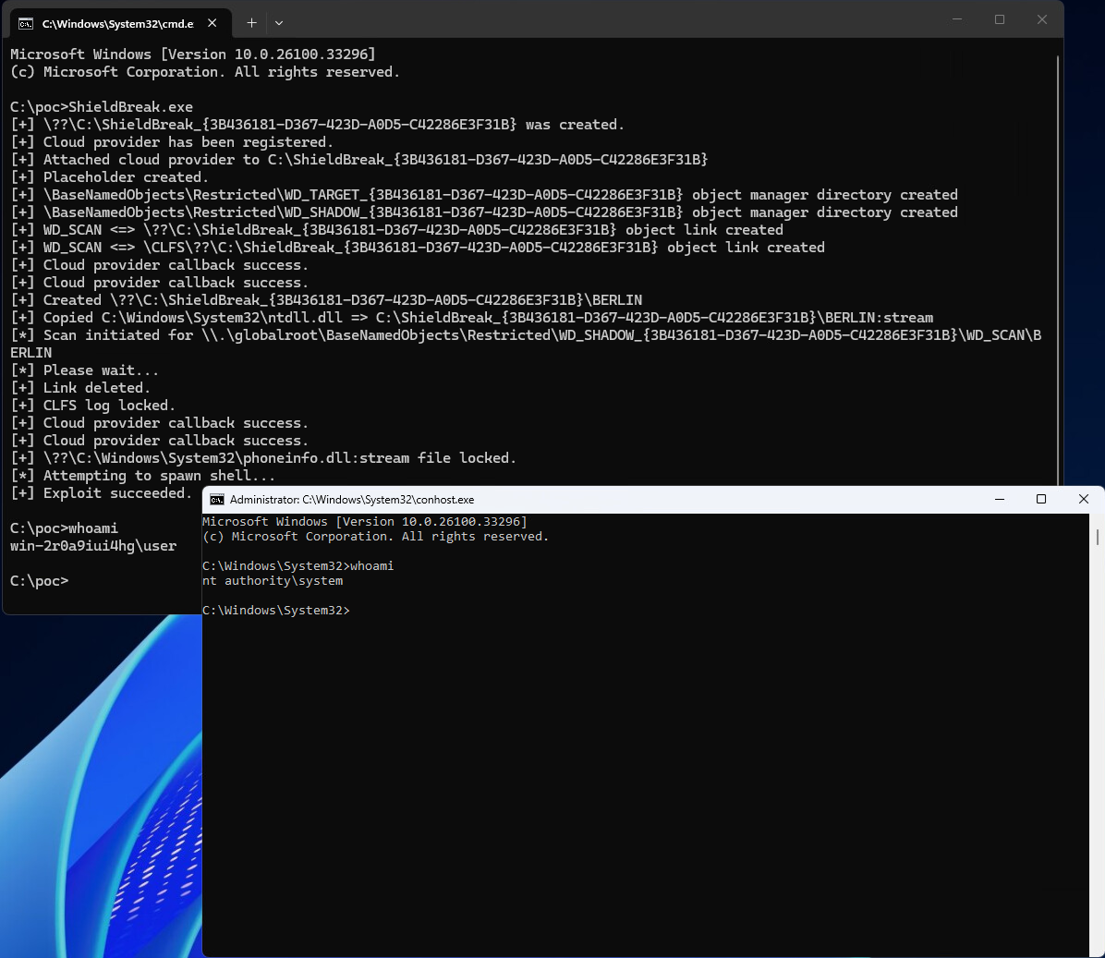
Figure 3. Documentary evidence only — the researcher's own console output, showing the PoC registering a cloud provider, locking a CLFS log, and spawning a shell that returns “nt authority\system.” Authenticity and environmental conditions are not independently verified by this report.
Credit: MSNightmare/ShieldBreak GitHub repository (researcher-published)

Is it really a “bypass” of the same bug? Independent researcher disagreement
This is the single most important open technical question for defenders assessing scope and remediation, and it comes directly from the two named researchers who actually reproduced ShieldBreak, not from vendor marketing copy:
- Kevin Beaumont distinguishes the two explicitly: "RoguePlanet was a filesystem race condition vuln that uses virtual disks," whereas ShieldBreak "uses a user-mode callback hook to change file contents during a Defender cloud-hydration scan via cfapi" — a different API surface, different primitive, different trigger path (via BleepingComputer).
- Will Dormann goes further, stating plainly that despite the "bypass" claim, "my naive eyeballs fail to see the similarity" between ShieldBreak’s cloud-provider/CLFS/hydration/phoneinfo.dll chain and RoguePlanet’s original mechanism, and separately notes ShieldBreak — unlike RoguePlanet — requires Windows Defender to be actively enabled and performing cloud-hydration scanning to work at all (infosec.exchange, Dormann).
Why this distinction matters operationally: if ShieldBreak exploits a *different* bug in the Cloud Filter API / CLFS integration rather than a genuine failure of the RoguePlanet fix, then (a) it likely warrants its own CVE and its own patch; (b) the "no fix exists" framing describes a newly discovered issue rather than an unresolved 60-day-old one; and (c) detection content built around RoguePlanet’s specific indicators will not reliably catch ShieldBreak. Several vendor write-ups published in the hours after ShieldBreak’s release still describe it as reusing RoguePlanet’s "race condition in mpengine.dll" (Arctic Wolf; Tanium) — this reflects genuine uncertainty and the rapid pace of early reporting rather than a settled technical consensus.

Prerequisites and constraints
Regardless of which root-cause account is correct, every technical source agrees on the exploitation prerequisites, which meaningfully bound the real-world risk:
- Local code execution is a prerequisite, not a byproduct. ShieldBreak is a privilege-escalation primitive, not an initial-access or remote-code-execution vulnerability (Tanium; ThreatLocker).
- Windows Defender must be enabled and actively performing cloud-hydration scanning. This is a notable divergence from RoguePlanet, which reportedly worked "whether or not Microsoft Defender Real-Time Protection is enabled" (Kudelski Security). ShieldBreak does not function against endpoints where Defender is disabled or fully replaced by third-party antivirus (Dormann via SecurityWeek).
- No user interaction is required beyond the attacker’s own actions once code execution exists (Cyberpress).
- Attack complexity assessments vary by source — RoguePlanet’s CVSS vector reports "Attack Complexity: High" (SentinelOne); ShieldBreak’s reported mechanism is described by the researcher as deterministic with a 100% success rate, though this has not been independently benchmarked across a large, diverse fleet (The Hacker News).

Affected and fixed version matrix

Component | Vulnerable | Fixed | Status vs. ShieldBreak
Microsoft Malware Protection Engine (mpengine.dll) | Prior to 1.1.26060.3008 (some sources anchor the floor at 1.1.26050.11) | 1.1.26060.3008 (Jul 8–9, 2026) | Not sufficient — ShieldBreak reportedly functions against this same “fixed” version
Windows 11 25H2 (incl. Canary channel builds) | Yes — explicitly tested | No fix for ShieldBreak | Confirmed vulnerable by two independent researchers
Windows Server 2025 | Yes — explicitly tested | No fix for ShieldBreak | Confirmed vulnerable by two independent researchers
Windows 10 and corresponding Server editions | Reported vulnerable by the researcher | No fix for ShieldBreak | Not independently confirmed
Endpoints with Defender disabled / replaced by third-party AV | Not exploitable via this mechanism | N/A | Requires active Defender cloud-hydration scanning

Two version-matrix caveats defenders should not skip
- Engine version, not OS build, is the control that matters for CVE-2026-50656. Verify the live engine version with Get-MpComputerStatus (AMEngineVersion) rather than assuming Windows Update compliance implies engine compliance (The Hacker News).
- Secondary sources disagree on the exact pre-patch version boundary — Qualys anchors it at "1.1.26050.11 and all earlier versions" (Qualys ThreatPROTECT) while SentinelOne states simply "prior to 1.1.26060.3008." Moot for remediation, but confirm exact version strings against the live MSRC advisory.

Is ShieldBreak being exploited in the wild?

What defenders can independently verify today
- CISA KEV catalog: a review of CISA’s catalog and its 2026 addition alerts through early-to-mid August 2026 did not surface an entry for CVE-2026-50656 (CISA KEV catalog).
- SentinelOne’s vulnerability database lists CVE-2026-50656 as "Known Exploited: No" and "Public PoC: Yes" (SentinelOne).
- Microsoft’s own public position is that it is "actively investigating the validity and potential applicability of these claims" — language that stops short of the "exploitation detected" phrasing Microsoft typically uses when it has telemetry showing active abuse (BleepingComputer).
- No incident-response vendor report, ransomware disclosure, or breach notification identified in this research ties an intrusion to ShieldBreak or to a RoguePlanet-derived technique.

Indirect risk signals defenders should weigh
- The researcher’s prior tooling has reportedly been operationalized quickly after release. Kudelski Security states earlier Nightmare Eclipse tools — BlueHammer and RedSun — "have appeared in live intrusions within weeks of public release" (Kudelski Security).
- The PoC is fully public and functional, lowering the barrier for both criminal actors and other researchers to weaponize or refine it.
- The exploit targets the security product itself, which — per Morphisec’s analysis — creates a uniquely dangerous blind spot (Morphisec).
Bottom line for risk triage: treat ShieldBreak as a credible, reproduced, unpatched local privilege-escalation primitive with no confirmed active campaign — a "patch now (once available), detect and harden in the meantime" posture rather than a "declare an incident" posture.

Detection guidance

No Microsoft-published detection rule exists yet, because Microsoft has not confirmed the vulnerability. The detection content below comes from independent researchers and vendors who reproduced or analyzed the PoC directly. Rules built for RoguePlanet’s original virtual-disk/reparse-point mechanism will likely not fire on ShieldBreak, which uses a different process chain.
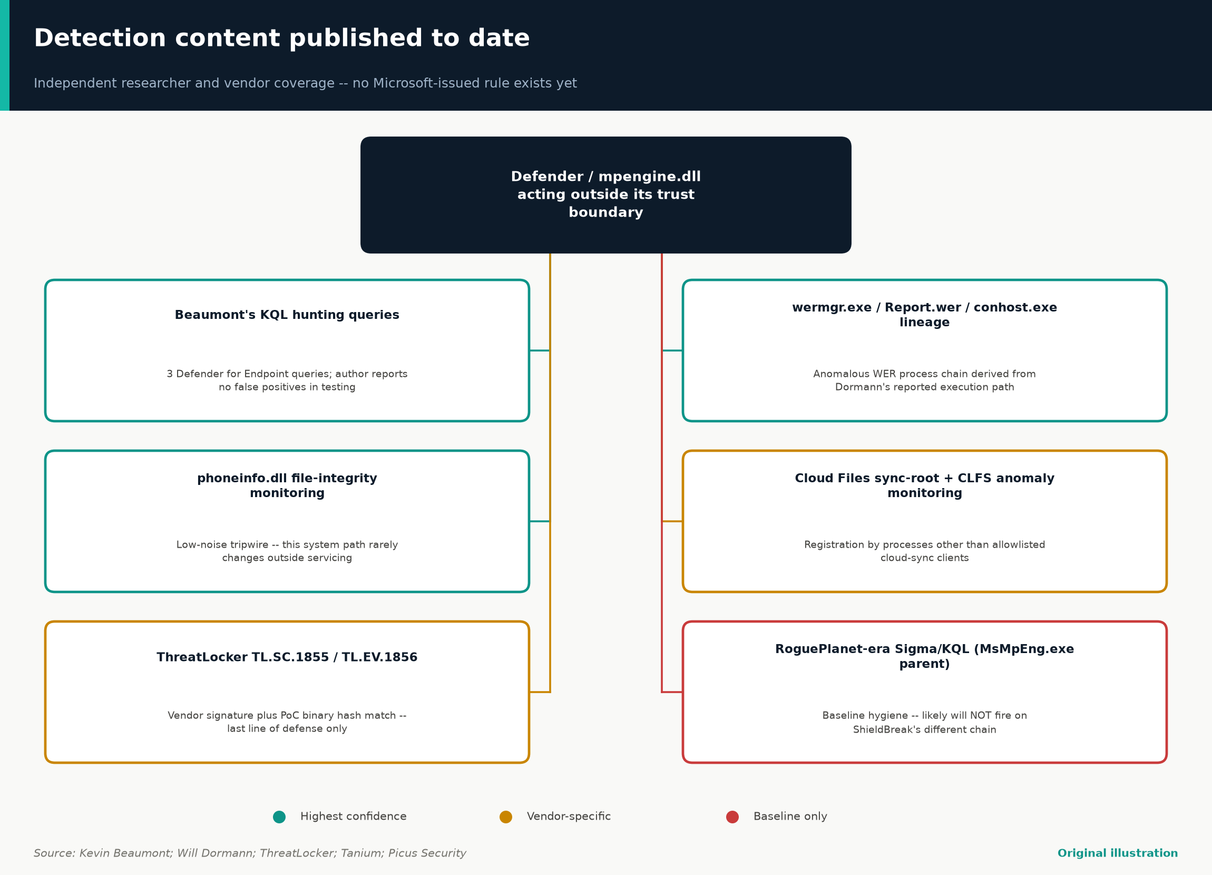
Figure 4. Six published detection signals, tiered by confidence — highest-confidence content is ShieldBreak-specific; the RoguePlanet-era rule is baseline coverage only.
Original illustration — based on Kevin Beaumont; Will Dormann; ThreatLocker; Tanium; Picus Security

Highest-confidence signal: Beaumont's ShieldBreak-specific hunting queries
Kevin Beaumont, after reproducing the exploit, published three detection and hunting queries for Microsoft Defender for Endpoint specifically targeting ShieldBreak’s behavior, reporting no false positives in his testing (Beaumont, Cyberplace/Mastodon). The published queries hunt for a process foreign to Microsoft Defender loading Defender’s own libraries, and unvalidated processes loading Cloud Filter API components (cldflt.sys-associated user-mode libraries) in a sequence consistent with cloud-sync-provider registration by a process with no legitimate reason to register one.

Process-lineage indicators from the reported technical chain
- wermgr.exe spawning child processes with -upload on the command line, where the parent/grandparent lineage does not match a genuine WER crash-upload flow (Tanium).
- Non-SYSTEM processes writing Report.wer files into the WER ReportQueue path (Tanium).
- conhost.exe spawned with a SYSTEM-integrity parent that is not a standard system service, particularly tracing back through wermgr.exe (Tanium).
- Unexpected creation or modification of C:\Windows\System32\phoneinfo.dll outside a Windows Update / servicing operation (Dormann via SecurityWeek).
- Anomalous registration of Cloud Files sync-root providers by processes other than known allowlisted cloud-sync clients, and unexpected CLFS log activity correlated with those registrations (SecurityAffairs).

RoguePlanet-era detection content (baseline hygiene, applicability caveat noted)
Prior to ShieldBreak's release, Picus Security published a general-purpose Sigma rule and equivalent Microsoft Defender for Endpoint KQL query for detecting an interactive shell or scripting host spawned directly by MsMpEng.exe at SYSTEM integrity — an anomaly that “should never occur in a healthy environment” (Picus Security):
title: SYSTEM Shell Spawned From Microsoft Defender Engine
logsource: {category: process_creation, product: windows}
detection:
selection:
ParentImage|endswith: '\MsMpEng.exe'
Image|endswith: ['\cmd.exe','\powershell.exe','\pwsh.exe',
'\conhost.exe','\cscript.exe','\wscript.exe']
condition: selection
level: high

DeviceProcessEvents
| where InitiatingProcessFileName =~ "MsMpEng.exe"
| where FileName in~ ("cmd.exe","powershell.exe","pwsh.exe",
"conhost.exe","cscript.exe","wscript.exe")
| where ProcessIntegrityLevel == "System"
Reproduced from Picus Security’s published analysis — defensive detection logic, not exploit code.

Important caveat: this rule keys on MsMpEng.exe as the *direct* process parent. Based on Dormann’s reported ShieldBreak chain, the SYSTEM-privileged shell surfaces via wermgr.exe → conhost.exe, not directly from MsMpEng.exe — meaning this rule, while valuable baseline coverage, may not fire on ShieldBreak. Picus separately lists this scenario under Threat ID 22090 (network infiltration) and Threat ID 27801 (email infiltration) (Picus Security).

Vendor-specific detections and file-based indicators
- ThreatLocker has published two detection signature IDs: TL.SC.1855 and TL.EV.1856 (ThreatLocker).
- Tanium customers can deploy the existing "Conhost Spawned Executable" Signal alongside custom rules for the wermgr.exe -upload / Report.wer pattern (Tanium).
- File hashes for the public PoC binaries have been published by ThreatLocker for ShieldBreak.exe and Warden.dll — treat hash-based detection as a last line of defense only (ThreatLocker).
- MITRE ATT&CK mapping, per Arctic Wolf: T1068 – Exploitation for Privilege Escalation, and T1574 – Hijack Execution Flow (Arctic Wolf).

Network indicators
Every source reviewed for this report is explicit that this is a local, host-based privilege-escalation technique with no meaningful network-based indicator of compromise for the escalation step itself (Arctic Wolf). Focus network monitoring on the initial-access stage and on post-escalation lateral-movement or C2 activity once SYSTEM is achieved.

Interim mitigations and hardening

There is no vendor patch for ShieldBreak as of this writing. The July 2026 Malware Protection Engine update (1.1.26060.3008) should still be applied as baseline hygiene, but do not treat it as sufficient (Cyberpress). Every mitigation below is a compensating control, not a fix, and several vendors flag that these controls can affect legitimate business applications and should be piloted before fleet-wide rollout.
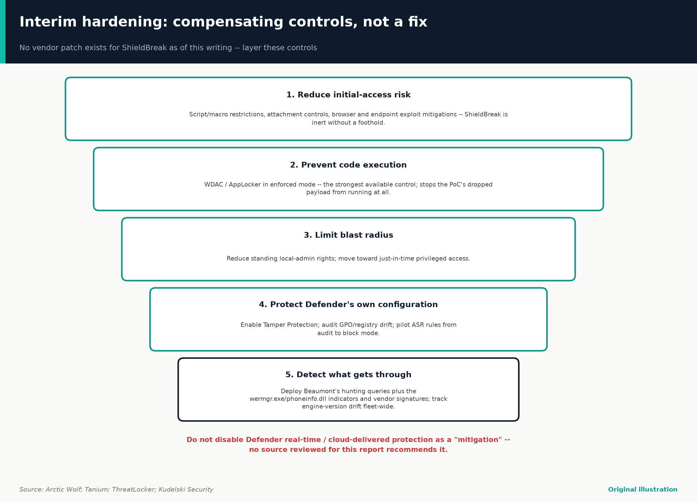
Figure 5. Five layers of compensating control, from reducing initial access down to detecting what gets through — narrower layers cover fewer endpoints but stop more of the chain.
Original illustration — based on Arctic Wolf; Tanium; ThreatLocker; Kudelski Security
- Application control / allowlisting is the strongest available compensating control. Enforcing WDAC or AppLocker in enforced mode prevents the ShieldBreak PoC’s dropped executable and payload DLL from running at all (Picus Security; ThreatLocker).
- Consider a targeted file-substitution tripwire. Tanium has published guidance for deploying a 0-byte placeholder file at the phoneinfo.dll path; pilot on a small group first (Tanium).
- Reduce standing local administrative rights and move toward just-in-time privileged access (Kudelski Security; Arctic Wolf).
- Enable and verify Microsoft Defender Tamper Protection fleet-wide, and audit GPO/registry-based Defender configuration for drift (Arctic Wolf).
- Deploy and pilot Attack Surface Reduction (ASR) rules, starting in audit mode and graduating to block mode (Arctic Wolf).
- Harden the initial-access stage aggressively, since this vulnerability is inert without a prior foothold (Kudelski Security).
- Deploy independently published detection content now so a successful exploitation attempt is caught even if prevention fails.
- Track Defender/MMPE engine version drift across the fleet as an ongoing hygiene metric (The Hacker News).
- Segment and monitor for lateral movement following any SYSTEM-level anomaly (Cloud Security Alliance).

What not to do
Do not interpret ShieldBreak’s dependency on active Defender cloud-hydration scanning as license to disable Defender real-time or cloud-delivered protection as a “mitigation” — doing so removes a broad set of detection and prevention capabilities in exchange for closing one narrow, PoC-specific path. No source reviewed for this report recommends disabling Defender.

The researcher, the disclosure fight, and why it matters for defenders

Understanding the disclosure context is not gossip — it materially affects how defenders should weight the urgency and reliability of this report:
- The researcher, using the handles Nightmare Eclipse / Chaotic Eclipse (and additional aliases including INFINITE NIGHTMARE and Dead Eclipse; GitHub account MSNightmare), has published a rapid cadence of Windows and Defender-related zero-days since roughly March–April 2026 — named releases reported across sources include BlueHammer, RedSun, UnDefend, YellowKey, GreenPlasma, MiniPlasma, LegacyHive, RoguePlanet, and now ShieldBreak (Cyberpress; BleepingComputer).
- The researcher has stated the disclosures are uncoordinated by design, citing frustration with Microsoft’s bug-bounty program, deleted MSRC reporting accounts, and inadequate response timelines (The Register; SecurityWeek).
- Microsoft has, per reporting, previously warned of potential legal action against "malicious activity causing real harm," while separately characterizing the uncoordinated disclosures as "irresponsible" (BleepingComputer; SecurityWeek).
- Claims of the researcher’s former Microsoft employment have circulated in press coverage but are described as the researcher’s own claim, not independently verified (The Register).
- The public GitHub repository for ShieldBreak provides minimal technical documentation — effectively a claim and a single proof screenshot, with no methodology write-up or coordinated-disclosure timeline (GitHub, MSNightmare/ShieldBreak). Everything substantive that defenders can act on has come from *independent* researchers (Dormann, Beaumont).
Practical implication: this is an adversarial, non-coordinated disclosure pattern from an actor explicitly motivated to maximize disruption around Microsoft’s patch cycle. That context argues for building durable behavioral detection capability around “Defender/mpengine.dll acting outside its expected trust boundary” as a standing detection category, rather than treating each named exploit as a one-off.

Open questions

- Is ShieldBreak genuinely a bypass of CVE-2026-50656’s root cause, or a distinct vulnerability? The two independent researchers who reproduced it lean toward "distinct mechanism," which several vendor blogs published in the first 24–48 hours have not yet caught up to (infosec.exchange, Dormann).
- Has Microsoft validated the claim, and if so, what will the fix be and when? As of writing, Microsoft has only committed to investigating (BleepingComputer).
- Does ShieldBreak actually work on Windows 10 and legacy Server editions, as the researcher claims? The public PoC does not demonstrate this (GitHub).
- How robust is the claimed 100% success rate across a genuinely diverse fleet? The researcher’s own account of RoguePlanet’s reliability noted it "struggled to work on" some machines (The Register).
- Is there any confirmed in-the-wild exploitation, of either RoguePlanet or ShieldBreak, beyond PoC demonstration? Not as of this writing (CISA KEV catalog; SentinelOne) — but the researcher’s prior tools have reportedly reached live intrusions within weeks in the past (Kudelski Security).
- Will Microsoft assign ShieldBreak a distinct CVE, or continue treating it as an extension of CVE-2026-50656?
- What does "fixed" ultimately require architecturally? Morphisec’s framing — that "the detector will keep being a target, because compromising the detector is the most efficient way to neutralize a defense" — suggests defenders should expect this vulnerability class, not just this specific bug, to recur (Morphisec).

Practical checklist for defenders

☐ Confirm Malware Protection Engine version is 1.1.26060.3008 or later fleet-wide via Get-MpComputerStatus (AMEngineVersion), not just Windows OS patch level.
☐ Deploy Beaumont’s published ShieldBreak-specific Defender for Endpoint hunting queries and validate for false positives (source).
☐ Add behavioral detection for wermgr.exe -upload child processes with anomalous lineage, non-SYSTEM writes to the WER ReportQueue path, and unexpected conhost.exe spawns at SYSTEM integrity via wermgr.exe.
☐ Add file-integrity monitoring on C:\Windows\System32\phoneinfo.dll.
☐ Deploy the RoguePlanet-era MsMpEng.exe-parent-shell Sigma/KQL rule as baseline coverage, understanding it likely will not catch ShieldBreak specifically.
☐ Enforce WDAC/AppLocker (or equivalent) in enforced mode; validate it blocks the public PoC binaries in a test environment.
☐ Pilot Tanium’s 0-byte phoneinfo.dll placeholder mitigation on a small ring before any broader rollout.
☐ Reduce standing local-admin rights; move toward just-in-time privileged access.
☐ Enable Defender Tamper Protection; audit Defender-related GPO/registry settings for drift.
☐ Pilot ASR rules in audit mode, graduate to block mode.
☐ Do not disable Defender real-time or cloud-delivered protection as a mitigation.
☐ Re-check the MSRC advisory for CVE-2026-50656 and the CISA KEV catalog on a recurring basis — this situation is unresolved and status can change quickly.

Visual assets and credits

This story is under 96 hours old at the time of research, and the vendor and news sources reviewed (Arctic Wolf, Tanium, Picus Security) publish only generic stock hero imagery and company logos alongside their coverage — no vendor has published a reusable technical diagram, attack-chain flowchart, or data chart for this specific incident. The one genuinely primary-source visual identified is the PoC screenshot embedded in the researcher’s own GitHub repository (Figure 3), reproduced here as documentary evidence of what the disclosure claims to show, not as an endorsement of the claim’s validity.
The four diagrams in this report (Figures 1, 2, 4, 5) are original illustrations produced for this report directly from the facts and citations documented above; they are not sourced from any vendor or news outlet.

Sources

# | Claim area | Source | Link
1 | CVE-2026-50656 official identifier and advisory | Microsoft Security Response Center | https://msrc.microsoft.com/update-guide/vulnerability/CVE-2026-50656
2 | RoguePlanet patch release, version 1.1.26060.3008, timeline | The Hacker News | https://thehackernews.com/2026/07/microsoft-patches-rogueplanet-defender.html
3 | ShieldBreak claims, mechanism, researcher/Microsoft statements | The Hacker News | https://thehackernews.com/2026/08/shieldbreak-zero-day-poc-claims.html
4 | ShieldBreak mechanism, Beaumont/Dormann quotes, Microsoft statement | BleepingComputer | https://www.bleepingcomputer.com/news/security/new-microsoft-defender-shieldbreak-zero-day-grants-system-privileges/
5 | Researcher history, motivation, Dormann's technical chain description | SecurityWeek | https://www.securityweek.com/nightmare-eclipse-drops-windows-zero-day-exploit-shieldbreak/
6 | ShieldBreak mechanism and affected versions | SecurityAffairs | https://securityaffairs.com/197063/hacking/shieldbreak-new-windows-zero-day-bypasses-microsofts-rogueplanet-patch.html
7 | RoguePlanet patch details and researcher background | SecurityAffairs | https://securityaffairs.com/195016/security/microsoft-fixed-defender-flaw-rogueplanet-cve-2026-50656.html
8 | Detection guidance, MITRE ATT&CK mapping, mitigation hierarchy | Arctic Wolf | https://arcticwolf.com/resources/blog/cve-2026-50656-rogueplanet-shieldbreak/
9 | Interim mitigations (0-byte placeholder), detection signals | Tanium | https://www.tanium.com/blog/shieldbreak-mitigation
10 | ShieldBreak PoC repository, claims, affected versions | GitHub — MSNightmare/ShieldBreak | https://github.com/MSNightmare/ShieldBreak
11 | RoguePlanet exploitation status, QIDs, affected versions | Qualys ThreatPROTECT | https://threatprotect.qualys.com/2026/06/18/microsoft-defender-zero-day-vulnerability-exploited-in-attacks-cve-2026-50656-rogueplanet/
12 | Root cause (CWE-59), detection/mitigation, weaponization-risk assessment | Kudelski Security | https://kudelskisecurity.com/research/rogueplanet-zero-day-ms-defender-privilege-escalation
13 | Root cause (TOCTOU, Volume Shadow Copy mechanism), detection, open questions | Cloud Security Alliance | https://labs.cloudsecurityalliance.org/research/csa-research-note-defender-rogueplanet-cve-2026-50656-202606/
14 | Technical anatomy, Sigma/KQL rules, ATT&CK mapping, threat-actor infrastructure | Picus Security | https://www.picussecurity.com/resource/blog/rogueplanet-anatomy-of-the-nightmare-eclipse-microsoft-defender-zero-day
15 | ShieldBreak mechanism, detection signature IDs, file hashes | ThreatLocker | https://www.threatlocker.com/blog/nightmareeclipse-releases-new-poc-shieldbreak-exploits-same-weakness-as-rogueplanet
16 | Timeline, Microsoft statement, researcher motivation/history | The Register | https://www.theregister.com/security/2026/07/09/microsoft-closes-book-on-nightmare-eclipses-rogueplanet-zero-day/5269280
17 | Patch Tuesday context, disclosure pattern | Rapid7 | https://www.rapid7.com/blog/post/em-patch-tuesday-august-2026/
18 | RoguePlanet patch confirmation, root cause, timeline | Help Net Security | https://www.helpnetsecurity.com/2026/07/09/microsoft-releases-fix-for-rogueplanet-defender-flaw-cve-2026-50656/
19 | CVSS vector/score, affected products, exploitation status | SentinelOne | https://www.sentinelone.com/vulnerability-database/cve-2026-50656/
20 | Architectural analysis of detector-as-attack-surface risk | Morphisec | https://www.morphisec.com/blog/microsoft-defender-zero-day-rogueplanet-when-your-detector-becomes-the-attack-surface/
21 | ShieldBreak mechanism, detection guidance, mitigation caveats | Cyberpress | https://cyberpress.org/shieldbreak-windows-defender-zero-day-bypasses/
22 | Researcher's broader campaign, distribution-infrastructure context | Cybersecurity News | https://cybersecuritynews.com/nightmare-eclipse-drops-shieldbreak-0-day/
23 | Independent technical reproduction and root-cause skepticism | Will Dormann, infosec.exchange | https://infosec.exchange/@wdormann/117079587486018149
24 | Independent skepticism that ShieldBreak is the “same” bug as RoguePlanet | Will Dormann, infosec.exchange | https://infosec.exchange/@wdormann/117083141042272544
25 | Independent confirmation of RoguePlanet mechanism description | Kevin Beaumont, Cyberplace/Mastodon | https://cyberplace.social/@GossiTheDog/117082623896479140
26 | Publication of ShieldBreak-specific detection/hunting queries | Kevin Beaumont, Cyberplace/Mastodon | https://cyberplace.social/@GossiTheDog/117082915912588664
27 | Absence of CVE-2026-50656 from confirmed-exploited-vulnerability tracking | CISA | https://www.cisa.gov/known-exploited-vulnerabilities-catalog
28 | ShieldBreak PoC screenshot (visual asset) | GitHub — MSNightmare/ShieldBreak | https://github.com/user-attachments/assets/184076b9-f703-4e56-a27d-007da717770f
Explore more questions at Ask Anything

