GLP-1–Based Therapeutics Beyond Weight Loss: Advanced Clinical Review and 2026 Breakthroughs
A researched, cited report · Ask Anything
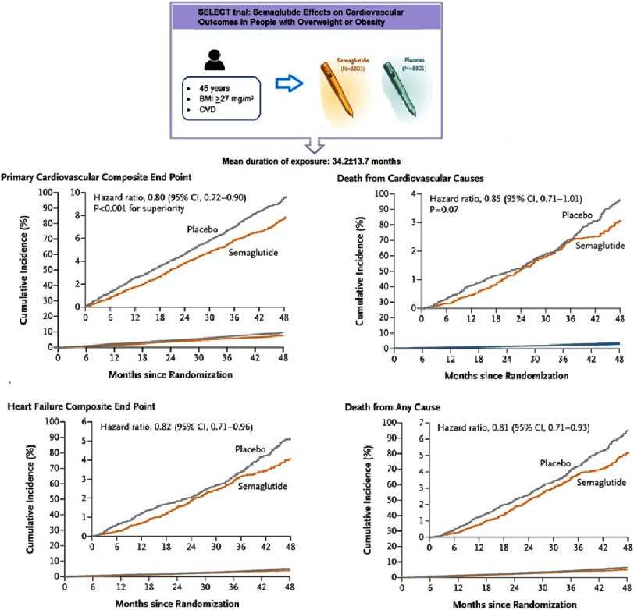
SELECT reframed obesity treatment as cardiovascular risk reduction in people with established disease. · Source: Banach et al., Global Cardiology Science & Practice (2024), Figure 3; summarizes SELECT

Executive clinical summary
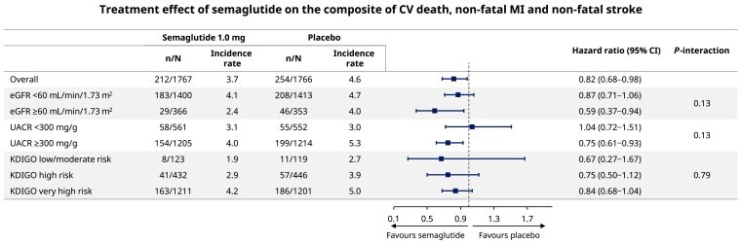
FLOW: cardiovascular outcomes with semaglutide across chronic kidney disease severity. · Source: FLOW secondary analysis, European Heart Journal (2025), Figure 2
GLP-1 medicines began as glucose-lowering drugs, became highly effective treatments for obesity, and are now changing care across several organ systems. By 2026, the strongest evidence beyond weight loss is not a vague claim that these medicines are universal anti-inflammatory agents. It comes from large randomized outcome trials showing fewer cardiovascular events, slower progression of diabetic kidney disease, better symptoms and physical function in obesity-related heart failure, fewer breathing interruptions in obstructive sleep apnea, improved liver histology in metabolic dysfunction-associated steatohepatitis, and less pain in people with obesity and knee osteoarthritis.
The effects differ by disease and population. Semaglutide reduced major cardiovascular events in SELECT among people with established cardiovascular disease and overweight or obesity but no diabetes. In FLOW, semaglutide reduced major kidney outcomes among people with type 2 diabetes and chronic kidney disease. Tirzepatide reduced sleep-apnea severity in adults with obesity and became the first FDA-approved medication for moderate-to-severe obstructive sleep apnea in that population. Semaglutide later received an accelerated FDA indication for noncirrhotic MASH with moderate-to-advanced fibrosis.
These results do not mean every patient should receive a GLP-1 drug, that all benefits are independent of weight loss, or that early signals in addiction and dementia are proven indications. Gastrointestinal adverse effects, gallbladder disease, loss of lean mass during weight reduction, drug interactions, pregnancy planning, peri-procedural aspiration concerns, cost, shortages, and long-term adherence all matter. Real-world discontinuation is common, particularly when insurance coverage is weak. The practical lesson is that GLP-1 therapy is becoming chronic risk-modifying medicine, but its value depends on matching the correct drug and indication to the correct patient and sustaining safe follow-up.

What these medicines actually are
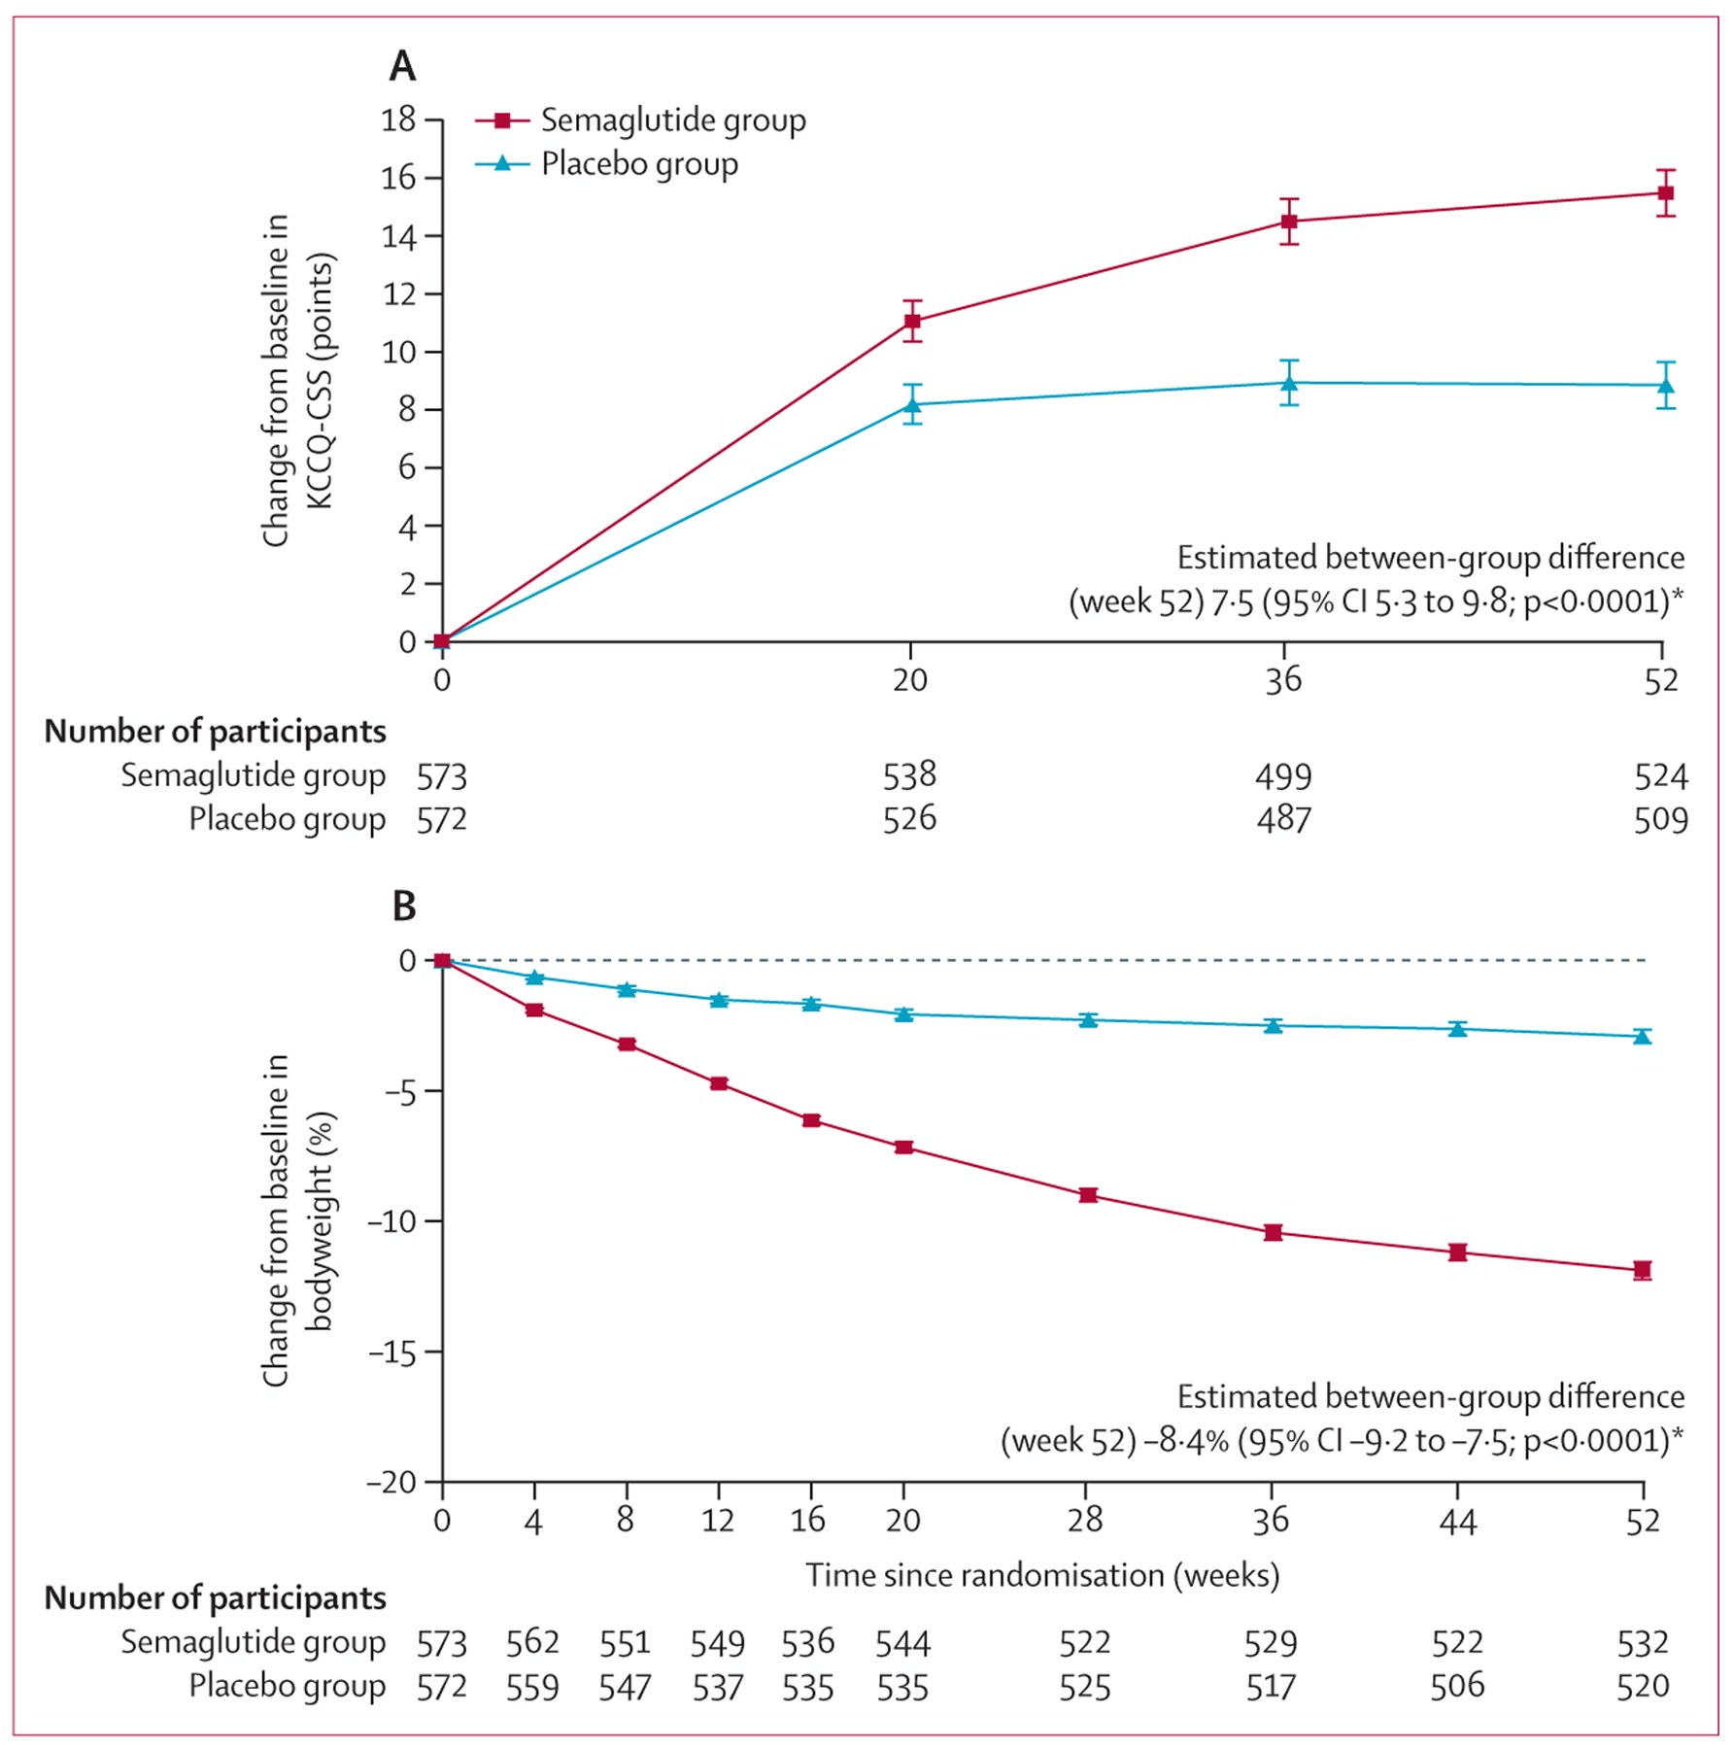
STEP-HFpEF pooled results: symptoms and body weight improved across people with and without diabetes. · Source: Butler et al., The Lancet (2024), Figure 1
Native glucagon-like peptide-1 is an intestinal hormone released after eating. It enhances glucose-dependent insulin secretion, suppresses glucagon when glucose is elevated, slows gastric emptying, and signals satiety through peripheral and central pathways. Medicinal GLP-1 receptor agonists resist rapid enzymatic breakdown, allowing daily or weekly dosing. Semaglutide is a selective GLP-1 receptor agonist. Tirzepatide activates both glucose-dependent insulinotropic polypeptide and GLP-1 receptors, so it is often described as a dual incretin agonist rather than a pure GLP-1 drug.
The class is heterogeneous. Liraglutide, dulaglutide, semaglutide, and tirzepatide differ in receptor activity, dose, formulation, approved uses, cardiovascular evidence, kidney evidence, and weight-loss efficacy. Brand names can also obscure indication-specific dosing: Ozempic and Wegovy contain semaglutide but are labeled for different populations and dose schedules; Mounjaro and Zepbound contain tirzepatide. A rigorous report therefore discusses the molecule, dose, studied population, and outcome rather than treating 'GLP-1' as a single interchangeable product.
Their multi-organ effects arise from several connected pathways. Reduced energy intake and weight lower mechanical load, visceral adiposity, blood pressure, sleep-apnea obstruction, and metabolic stress. Improved glycemia and insulin sensitivity reduce microvascular injury. Natriuresis, altered inflammation, endothelial effects, and direct receptor signaling may contribute in some tissues. The proportion of benefit attributable to weight loss versus other mechanisms varies by outcome and remains an active area of research.

Molecular pharmacology and receptor biology
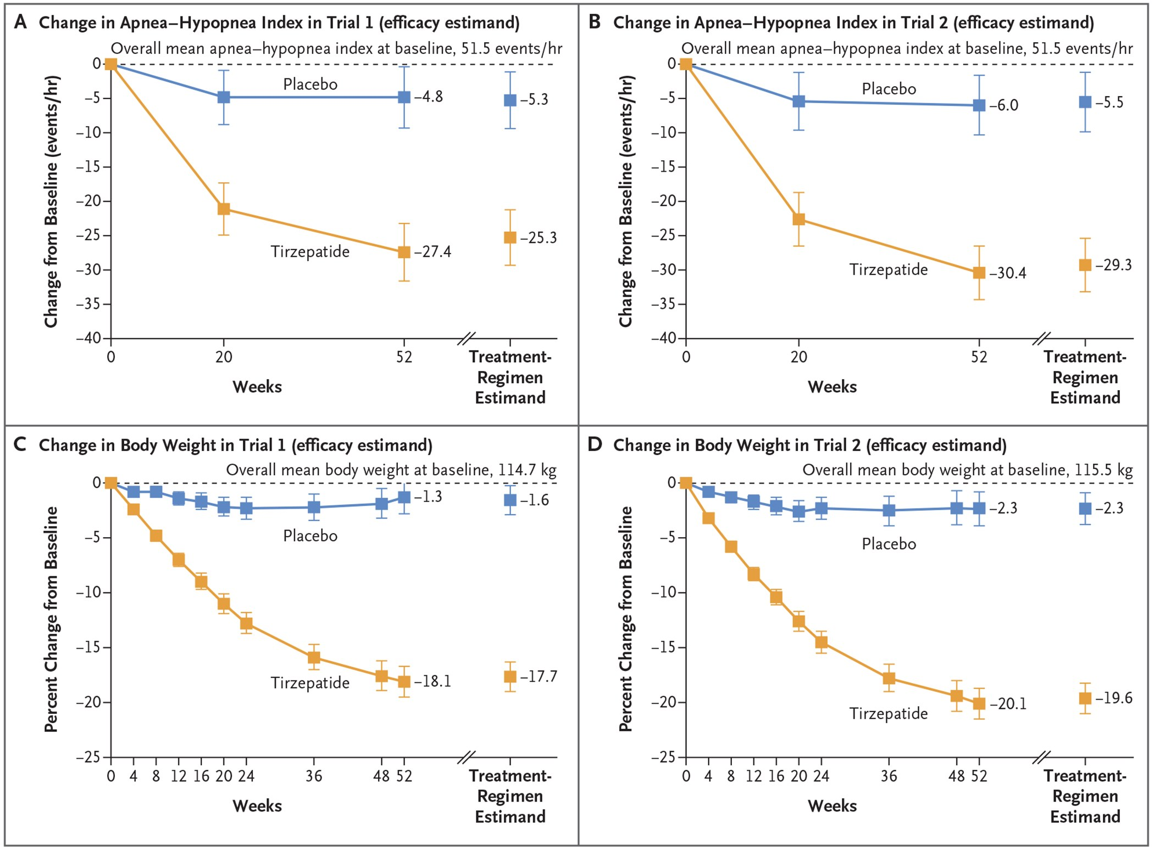
SURMOUNT-OSA participant flow and trial structure across PAP and non-PAP cohorts. · Source: Malhotra et al., New England Journal of Medicine (2024), Figure 1; PMC author manuscript
GLP-1 receptor agonists activate the class B G-protein-coupled GLP-1 receptor, increasing cyclic AMP and protein kinase A signaling in pancreatic beta cells. Insulin secretion is glucose dependent, which limits intrinsic hypoglycemia risk unless treatment is combined with insulin or an insulin secretagogue. Suppression of inappropriate glucagon, delayed gastric emptying, and central effects on satiety networks contribute to glycemic and weight outcomes. Tachyphylaxis to gastric-emptying effects occurs with long-acting agents, whereas central and pancreatic effects persist.
Semaglutide is a human GLP-1 analogue modified for dipeptidyl-peptidase-4 resistance and albumin binding, producing an approximately one-week half-life. Tirzepatide is an acylated peptide with dual GIP-receptor and GLP-1-receptor agonism. Receptor balance, biased signaling, tissue exposure, dose, and trial population complicate class-wide extrapolation. Cardiovascular or kidney outcome evidence for one agent should not be assigned automatically to another agent lacking an equivalent outcomes program.
Weight-dependent pathways include reductions in visceral and ectopic adiposity, blood pressure, mechanical load, OSA-related upper-airway collapsibility, insulin resistance, and systemic metabolic demand. Candidate weight-independent pathways include improved endothelial function, natriuresis, altered inflammatory signaling, reduced oxidative stress, and direct effects in the kidney, heart, liver, and central nervous system. Mediation analyses suggest that not all cardiovascular or kidney benefit is explained by achieved weight loss, but such analyses cannot prove a direct receptor effect in a specific organ.
Pharmacokinetic considerations are clinically relevant. Severe renal impairment does not necessarily mandate semaglutide dose adjustment, but volume depletion from gastrointestinal toxicity can precipitate acute kidney injury. Delayed gastric emptying can alter the rate of oral drug absorption and create retained gastric contents during anesthesia. The long half-life means that adverse effects and peri-procedural considerations may persist after the most recent weekly dose.

Pivotal trial architecture and quantitative interpretation
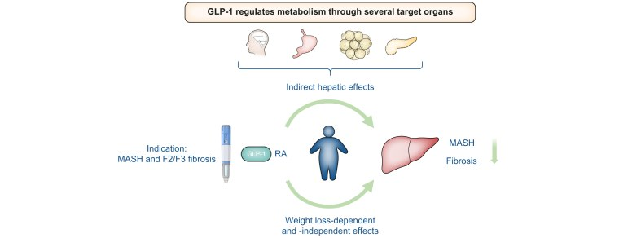
ESSENCE links metabolic treatment to improvement in steatohepatitis and fibrosis. · Source: Ratziu et al., United European Gastroenterology Journal (2025), Figure 1
SELECT was a secondary-prevention, event-driven cardiovascular outcomes trial rather than a weight-loss efficacy study. It enrolled 17,604 adults aged at least 45 years with BMI at least 27 kg/m2, established atherosclerotic cardiovascular disease, and no diabetes. Semaglutide 2.4 mg reduced three-point MACE from 8.0% to 6.5% over a mean 39.8 months (HR 0.80, 95% CI 0.72-0.90). The absolute risk reduction was 1.5 percentage points, corresponding to an approximate number needed to treat of 67 over the observed follow-up, although time-to-event NNT estimates should be interpreted cautiously. Permanent discontinuation due to adverse events was 16.6% versus 8.2%.
FLOW enrolled 3,533 patients with type 2 diabetes and high-risk CKD defined by eGFR and albuminuria thresholds. Semaglutide 1.0 mg reduced the primary composite of kidney failure, sustained at least 50% eGFR reduction, or kidney/cardiovascular death by 24%; the trial stopped early after a prespecified interim analysis. Interpretation should account for background renin-angiotensin system blockade, incomplete contemporary SGLT2-inhibitor use, early stopping, and the composite contribution of cardiovascular death.
STEP-HFpEF and STEP-HFpEF DM used dual primary endpoints of KCCQ clinical summary score and body weight, with supportive functional, inflammatory, and hierarchical composite outcomes. These trials established a clinically meaningful symptom and function signal in obesity-related HFpEF, but they were not individually powered for mortality. Tirzepatide's SUMMIT program subsequently added event-level evidence for cardiovascular death or worsening HF in HFpEF with obesity.
SURMOUNT-OSA used two parallel phase 3 trials stratified by PAP use. Mean baseline AHI approached 50 events per hour. Tirzepatide produced treatment differences of approximately 20 to 24 fewer AHI events per hour versus placebo, alongside improvements in hypoxic burden, body weight, systolic pressure, and high-sensitivity CRP. The design supports use in moderate-to-severe OSA with obesity; it does not establish efficacy for central sleep apnea or OSA without obesity.
ESSENCE evaluated histologic endpoints in biopsy-confirmed MASH with F2-F3 fibrosis. Accelerated approval rests on resolution of steatohepatitis without fibrosis worsening and fibrosis improvement without steatohepatitis worsening. These surrogate histologic endpoints are clinically meaningful but require confirmation against decompensation, cirrhosis, transplantation, and liver-related mortality.

Breakthroughs through 2026: what changed clinical practice
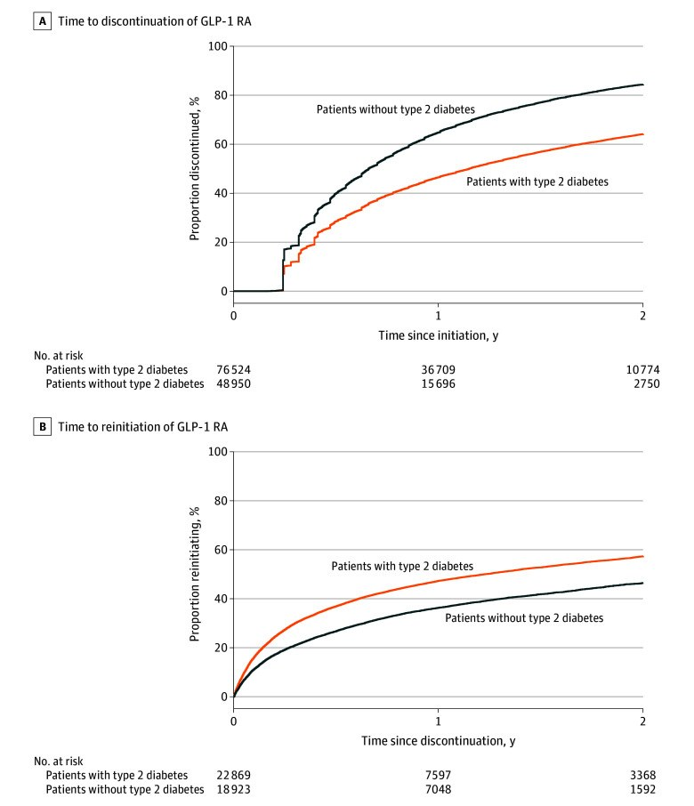
Real-world discontinuation is substantially higher among people without type 2 diabetes. · Source: Rodriguez et al., JAMA Network Open (2025), Figure 1
- Cardiovascular disease: semaglutide moved obesity pharmacotherapy into labeled secondary cardiovascular prevention after SELECT.
- Chronic kidney disease: the Ozempic label expanded to reduce sustained eGFR decline, end-stage kidney disease, and cardiovascular death in adults with type 2 diabetes and CKD after FLOW.
- Sleep medicine: tirzepatide became the first FDA-approved pharmacotherapy for moderate-to-severe OSA in adults with obesity.
- Hepatology: semaglutide received accelerated approval for noncirrhotic MASH with F2-F3 fibrosis, creating a new metabolic-liver treatment pathway.
- HFpEF: randomized symptom/function evidence matured into event-level evidence for incretin-based treatment of the obesity phenotype.
- Delivery technology: high-dose oral semaglutide and next-generation multi-agonists expanded the pipeline, while long-term outcome evidence remained the decisive threshold for adoption.
- Precision selection: indication-specific labels increasingly require clinicians to phenotype obesity complications rather than prescribe solely by BMI.

Cardiovascular prevention: SELECT changed the label
SELECT enrolled 17,604 adults aged 45 years or older with established cardiovascular disease and a body-mass index of at least 27, but without diabetes. Participants received semaglutide 2.4 mg weekly or placebo in addition to standard care. Over a mean follow-up of 39.8 months, cardiovascular death, nonfatal myocardial infarction, or nonfatal stroke occurred in 6.5% of the semaglutide group and 8.0% of the placebo group. The hazard ratio was 0.80, a 20% relative reduction; the absolute difference was 1.5 percentage points in this secondary-prevention population.
This is clinically different from showing improvement in cholesterol, blood pressure, or a laboratory surrogate. It is an outcomes trial showing fewer serious events. The result supported the US indication for reducing major adverse cardiovascular events in adults with established cardiovascular disease and overweight or obesity. It should not be generalized to primary prevention in otherwise low-risk adults, because SELECT did not enroll that population.
Real-world example: consider a 61-year-old with a prior myocardial infarction, BMI 33, no diabetes, and appropriate statin and antiplatelet treatment. This profile resembles the SELECT population. Semaglutide would not replace established secondary-prevention therapy; it could be considered as an additional risk-modifying treatment when obesity or overweight is present. The decision still depends on contraindications, tolerability, affordability, and shared goals. This is a representative clinical scenario derived from trial eligibility, not an invented treatment success story.

Kidney disease: FLOW moved from surrogate markers to outcomes
FLOW randomized 3,533 people with type 2 diabetes and chronic kidney disease to semaglutide 1.0 mg weekly or placebo. Eligibility required reduced estimated glomerular filtration rate and substantial albuminuria, identifying patients at high risk of kidney failure and cardiovascular death. The primary composite included kidney failure, a sustained loss of at least 50% of eGFR, or death from kidney or cardiovascular causes. The trial was stopped early after a prespecified interim analysis demonstrated efficacy.
Semaglutide reduced the risk of major kidney disease events by 24%, slowed annual eGFR decline, and improved cardiovascular and survival outcomes. This is important because earlier GLP-1 trials often treated albuminuria or kidney outcomes as secondary measures. FLOW was designed specifically around kidney disease progression. In practice, GLP-1 therapy complements rather than automatically replaces renin-angiotensin system blockade, SGLT2 inhibitors, blood-pressure management, and finerenone when those are appropriate.
Real-world example: a patient with type 2 diabetes, eGFR 42, persistent macroalbuminuria, and high cardiovascular risk resembles the FLOW population more closely than a person with normal kidney function and minimal albuminuria. Treatment selection should reflect the full evidence-based kidney regimen and the patient's ability to tolerate it. During acute illness with vomiting or dehydration, clinicians may need to reassess medicines because volume depletion can worsen kidney function even when the long-term kidney effect is beneficial.

Heart failure with preserved ejection fraction
Obesity-related heart failure with preserved ejection fraction is characterized by breathlessness, exercise intolerance, congestion, inflammation, and impaired quality of life. STEP-HFpEF and STEP-HFpEF DM tested semaglutide 2.4 mg in people with obesity-related HFpEF without and with type 2 diabetes. Across the program, semaglutide produced larger improvements in the Kansas City Cardiomyopathy Questionnaire clinical summary score, greater weight reduction, longer six-minute walk distance, and lower inflammatory markers than placebo.
Tirzepatide subsequently reduced a composite of cardiovascular death or worsening heart failure and improved health status in people with HFpEF and obesity. These trials support the idea that obesity can be a treatable driver of a heart-failure phenotype rather than merely a coexisting diagnosis. They do not make GLP-1 or dual-incretin therapy a substitute for diuretics, SGLT2 inhibitors, blood-pressure control, rhythm management, or evaluation for other causes of dyspnea.
Real-world example: a 68-year-old with BMI 38, preserved ejection fraction, exertional dyspnea, edema controlled with diuretics, and low KCCQ score resembles the studied phenotype. A clinician would first confirm HFpEF and exclude alternative explanations. If incretin therapy is added, success is not measured only in kilograms; symptom burden, walking capacity, congestion, blood pressure, glucose, adverse effects, and heart-failure events all matter.

Obstructive sleep apnea: the first medication approval
SURMOUNT-OSA included two 52-week randomized trials in adults with moderate-to-severe obstructive sleep apnea and obesity. One trial enrolled participants unable or unwilling to use positive airway pressure, and the other enrolled participants using PAP. Baseline apnea-hypopnea index was about 50 events per hour, indicating severe disease. Tirzepatide produced substantially larger reductions in AHI, body weight, hypoxic burden, and inflammatory markers than placebo.
In the two trials, mean reductions in AHI were approximately 25 to 29 events per hour with tirzepatide versus about 5 events per hour with placebo, depending on the trial and estimand. The FDA approved Zepbound for moderate-to-severe OSA in adults with obesity, used with reduced-calorie diet and increased physical activity. This was the first drug approval for a defined OSA population, but PAP, oral appliances, surgery, positional therapy, and management of nasal or craniofacial factors remain important.
Real-world example: an adult with BMI 41 and severe OSA who cannot consistently tolerate PAP resembles one SURMOUNT-OSA cohort. Tirzepatide may reduce disease severity, but follow-up sleep testing is important before deciding that PAP is no longer needed. Someone with central sleep apnea, mild OSA without obesity, or upper-airway obstruction unrelated to adiposity falls outside the approved population.

Liver disease: MASH became an approved indication
Metabolic dysfunction-associated steatohepatitis combines hepatic steatosis, inflammation, hepatocyte injury, and risk of fibrosis progression. In the phase 3 ESSENCE trial interim analysis, 800 participants with biopsy-confirmed MASH and fibrosis stages F2 or F3 received semaglutide 2.4 mg or placebo. At 72 weeks, semaglutide improved both resolution of steatohepatitis without worsening fibrosis and improvement in fibrosis without worsening steatohepatitis.
The FDA granted accelerated approval for Wegovy in adults with noncirrhotic MASH and moderate-to-advanced fibrosis. Accelerated approval matters: the indication is based on improvement in histology, and continued approval may depend on confirmation of clinical benefit such as reduced progression to cirrhosis, decompensation, transplantation, or liver-related death. The drug is not labeled as a cure for fatty liver in every person and was not approved for decompensated cirrhosis.
Real-world example: a patient with obesity, type 2 diabetes, biopsy or validated noninvasive evidence consistent with F2-F3 fibrosis, and no cirrhosis resembles the labeled population. Treatment should sit inside liver care that addresses alcohol exposure, viral hepatitis, cardiovascular risk, diabetes, nutrition, and surveillance. Improvement in liver enzymes alone is not equivalent to fibrosis regression.

Knee osteoarthritis: less weight, less pain, better function
STEP 9 randomized 407 adults with obesity and moderate knee osteoarthritis pain to semaglutide 2.4 mg or placebo, both with lifestyle counseling. At 68 weeks, mean weight change was -13.7% with semaglutide and -3.2% with placebo. WOMAC pain scores improved by 41.7 points versus 27.5 points, and physical-function scores improved more with semaglutide. Gastrointestinal effects were the most common reason for discontinuation.
This is an example of benefit mediated substantially through treatment of obesity and mechanical load, with possible metabolic or inflammatory contributions. Semaglutide is not FDA-approved specifically as a disease-modifying osteoarthritis drug, and the study did not prove cartilage regeneration. It may help a selected patient move, participate in physical therapy, or become a safer surgical candidate, but it does not replace strength training, analgesic planning, injections when appropriate, or arthroplasty for advanced disease.
Real-world example: a 56-year-old with BMI 40, radiographic knee osteoarthritis, severe activity-related pain, and limited mobility resembles the STEP 9 population. Useful outcomes include walking, sleep, ability to work, analgesic use, and readiness for surgery—not only scale weight.

The evidence map: proven, plausible, and premature
- Proven in defined populations: type 2 diabetes control, chronic weight management, cardiovascular risk reduction with semaglutide in established cardiovascular disease and overweight/obesity, tirzepatide for moderate-to-severe OSA with obesity, and semaglutide for noncirrhotic MASH with F2-F3 fibrosis.
- Strong randomized evidence but indication-specific practice varies: diabetic kidney disease, obesity-related HFpEF, and knee osteoarthritis symptoms in people with obesity.
- Promising but not established treatment indications: alcohol use disorder, dementia prevention, Parkinson disease, polycystic ovary syndrome, and several inflammatory conditions.
- Unsupported shortcut: assuming that a benefit observed with one molecule, dose, and population applies to every GLP-1 medicine or every patient.

Addiction and the brain: an important signal, not a clinical conclusion
Reports of reduced alcohol desire led to mechanistic studies and clinical trials. A small phase 2 randomized trial in 48 adults with alcohol use disorder found that low-dose semaglutide reduced some laboratory and self-reported drinking outcomes. Open-access mechanistic work and observational studies also suggest altered reward, craving, and ingestive behavior. These findings justify larger trials but do not establish semaglutide as an approved treatment for alcohol use disorder.
Dementia evidence is similarly nuanced. A meta-analysis of randomized cardiovascular and diabetes trials found an association between GLP-1 receptor agonists and lower reported dementia or cognitive impairment, but cognition was usually not the primary outcome and event ascertainment varied. Dedicated neurodegeneration trials are needed. Patients should not start or continue these medicines solely to prevent Alzheimer's disease on the basis of current evidence.
The correct public message is neither dismissal nor hype. Central GLP-1 pathways affect satiety and reward, and metabolic health affects brain health. Those biological connections are credible. Whether they translate into clinically meaningful prevention or treatment of addiction and neurodegeneration remains unresolved.

Safety, contraindications, and monitoring
Nausea, vomiting, diarrhea, constipation, abdominal pain, and reflux are common, especially during dose escalation. Slower titration, smaller meals, hydration, and review of interacting medicines may help, but persistent severe symptoms require assessment. Gallbladder disease can occur, particularly during rapid weight loss. Pancreatitis is uncommon but serious abdominal pain requires evaluation. Severe vomiting or poor intake can contribute to dehydration and acute kidney injury.
Semaglutide and tirzepatide labels carry boxed warnings about thyroid C-cell tumors observed in rodents and are contraindicated in people with a personal or family history of medullary thyroid carcinoma or multiple endocrine neoplasia syndrome type 2. They are not used during pregnancy for weight reduction; medication-specific washout and pregnancy planning should be discussed. When combined with insulin or insulin secretagogues, doses may need adjustment to reduce hypoglycemia risk.
Delayed gastric emptying can affect oral drug absorption and creates concern during anesthesia or deep sedation. Rare postmarketing pulmonary aspiration has been reported despite fasting. Patients should tell surgical and anesthesia teams that they use an incretin medicine; peri-procedural management should be individualized according to current multidisciplinary guidance, symptoms, dose escalation, and procedure risk.
Weight loss includes fat and lean tissue. Resistance exercise, adequate protein when medically appropriate, and monitoring of strength and function are particularly important in older adults, people with frailty, and those losing weight rapidly. A lower number on the scale is not a good outcome if it comes with dehydration, malnutrition, or loss of independence.

What happens when treatment stops
Obesity is chronic and biological defenses against weight loss persist. In SURMOUNT-4, participants lost a mean 20.9% during 36 weeks of open-label tirzepatide. Those switched to placebo regained about 14% from the randomization point over the next year, while those who continued treatment lost an additional 5.5%. Withdrawal studies with semaglutide show the same direction: stopping commonly leads to weight regain and loss of cardiometabolic improvements.
Real-world persistence is lower than in trials. In a US electronic-health-record cohort of 125,474 adults starting liraglutide, semaglutide, or tirzepatide for overweight or obesity, estimated one-year discontinuation was 46.5% among people with diabetes and 64.8% among those without diabetes. Gastrointestinal events, income, insurance, drug availability, and achieved weight loss were associated with stopping or restarting.
This changes how benefit should be discussed before prescribing. A three-month cosmetic intervention is a poor mental model. Clinicians and patients need a long-term plan covering dose, monitoring, nutrition, activity, maintenance, affordability, supply interruptions, and alternatives. Stopping is not a moral failure, and regain is not evidence that the medicine never worked; it reflects loss of an active therapy in a chronic disease.

Access, equity, and real-world delivery
The people most likely to benefit are not always the people most able to obtain sustained treatment. Coverage differs by diagnosis, payer, country, prior authorization, and employer plan. A cardiovascular, OSA, or MASH indication may change eligibility, but it does not guarantee access. Shortages and fragmented follow-up can interrupt titration or encourage unsafe use of unregulated products.
Trial populations also do not perfectly represent clinical practice. SELECT included relatively few women compared with many obesity trials. Frail older adults, people with advanced gastrointestinal disease, pregnant patients, and individuals with complex multimorbidity may be underrepresented or excluded. Real-world care needs medication reconciliation, culturally appropriate nutrition support, protection against eating-disorder harms, and outcome monitoring beyond body weight.
A responsible program measures who starts, who reaches a tolerated dose, who stops, why they stop, and whether cardiovascular, kidney, sleep, liver, function, and quality-of-life outcomes improve. Without that operational layer, an effective medicine can still produce inequitable or disappointing population results.

A clinician and patient decision framework
- Define the treatment target: glucose, chronic weight management, cardiovascular risk, kidney disease, OSA, MASH, HFpEF symptoms, or another goal.
- Match the exact molecule, dose, label, and trial population; do not rely on class-wide assumptions.
- Screen contraindications, pregnancy plans, gastrointestinal disease, gallbladder and pancreatitis history, retinopathy risk when glucose may fall rapidly, frailty, and interacting medicines.
- Agree on meaningful outcomes: events avoided, albuminuria/eGFR, sleep study, liver assessment, symptoms, mobility, function, glucose, weight, and quality of life.
- Build the maintenance plan before the first dose, including coverage, follow-up, nutrition, resistance exercise, adverse-effect management, and a safe plan if supply ends.

Choosing a medicine by evidence, not popularity
The first question is not which product produces the largest average weight change. It is which outcome matters for this patient and which molecule has evidence for that outcome. A person with established cardiovascular disease and overweight or obesity but no diabetes maps directly to the semaglutide SELECT evidence and cardiovascular label. A person with obesity and moderate-to-severe obstructive sleep apnea maps to the tirzepatide SURMOUNT-OSA evidence and OSA label. A person with biopsy-confirmed noncirrhotic F2-F3 MASH maps to the semaglutide MASH indication. These are not interchangeable claims.
For type 2 diabetes with chronic kidney disease, semaglutide has a dedicated kidney-outcomes trial, while SGLT2 inhibitors and finerenone have their own complementary evidence and eligibility constraints. For obesity-related HFpEF, both semaglutide and tirzepatide have important randomized results, but clinicians must integrate those findings with the rest of heart-failure therapy and local approval or reimbursement. For knee osteoarthritis, semaglutide improved pain and function in a specific obesity population, but there is no osteoarthritis-specific label and no proof that it repairs cartilage.
Dose and formulation also matter. Trial outcomes belong to the tested regimen; a lower diabetes dose, compounded preparation, or different molecule cannot automatically inherit the same magnitude of benefit. Switching between products may require re-titration and new authorization. Oral and injectable formulations have different administration requirements, exposures, and evidence packages. The brand name should never substitute for medication reconciliation.
A practical evidence hierarchy is useful: first, regulatory indication and randomized outcome trial in a matching population; second, strong randomized evidence without a specific label; third, observational association or secondary analysis; fourth, mechanistic or animal evidence. The lower the evidence tier, the more clearly uncertainty should be communicated and the less appropriate it is to market the use as an established benefit.

Clinical phenotypes and representative decision vignettes
Cardiovascular journey: a 59-year-old with prior ischemic stroke, BMI 31, no diabetes, and optimized vascular prevention asks whether semaglutide is only for weight loss. The evidence-based answer is that SELECT included people like this and showed fewer major cardiovascular events. The care plan would document the secondary-prevention indication, screen contraindications, titrate gradually, and monitor both tolerability and vascular risk factors. The absolute benefit depends on baseline risk and duration of treatment.
Kidney journey: a 66-year-old with type 2 diabetes, eGFR 38, macroalbuminuria, and hypertension is already taking an ACE inhibitor and an SGLT2 inhibitor. FLOW supports adding semaglutide for a patient with this risk pattern if otherwise appropriate. The goal is not merely a lower A1c or smaller waist; it is slower progression to kidney failure and fewer cardiovascular events. Follow-up would include eGFR, albuminuria, blood pressure, glucose, hydration, nutrition, and adverse effects.
Sleep journey: a 48-year-old with BMI 42 and severe OSA struggles to use PAP through the night. Tirzepatide may be considered because the patient resembles SURMOUNT-OSA participants, but the treatment is combined with nutrition and activity support and does not authorize self-discontinuation of PAP. Repeat sleep assessment after meaningful weight change helps determine residual disease and whether other airway treatment is still needed.
Liver journey: a 52-year-old with diabetes and obesity has elevated liver enzymes and ultrasound steatosis. That alone does not establish the MASH indication. The next step is fibrosis risk stratification and hepatology evaluation, using validated noninvasive tests and sometimes biopsy. If noncirrhotic F2-F3 MASH is confirmed, semaglutide can be discussed alongside the accelerated-approval limitations and comprehensive metabolic and liver care.
Mobility journey: a 57-year-old with BMI 39 and painful knee osteoarthritis cannot exercise comfortably and is being evaluated for arthroplasty. STEP 9 supports the possibility that semaglutide-assisted weight reduction can improve pain and function. A combined plan would include progressive strengthening, physical therapy, analgesic review, nutrition, and orthopedic follow-up. The aim is greater mobility and surgical readiness, not a promise that injections regrow cartilage.
Discontinuation journey: a 43-year-old loses 18% of body weight with tirzepatide but loses insurance coverage. The care team anticipates increased appetite and weight regain rather than blaming the patient. They explore an appeal based on indications and comorbidities, alternative therapies, behavioral and nutrition support, and safe dose transition. This scenario reflects why cost and continuity are clinical variables, not administrative footnotes.

How a real health system should implement GLP-1 care
A safe program begins with intake and eligibility rather than automatic prescribing. The intake records diagnosis, prior therapies, cardiovascular and kidney history, sleep apnea, liver fibrosis risk, pregnancy plans, gastrointestinal symptoms, eating-disorder history, frailty, medications that can cause hypoglycemia, and previous response to incretin therapy. The clinician selects a target outcome and documents why the chosen medicine matches the evidence.
Dose escalation should be linked to tolerability rather than a race to the maximum dose. Structured follow-up at initiation and each escalation can identify persistent vomiting, dehydration, severe constipation, gallbladder symptoms, disordered eating, excessive caloric restriction, and loss of strength. Diabetes medicines may need adjustment as glucose falls. Older adults and people with CKD require especially careful attention to hydration, protein needs, muscle function, and polypharmacy.
Outcome measurement should be organ specific. Cardiovascular programs track events, blood pressure, lipids, smoking, and adherence to standard prevention. Kidney programs track eGFR slope and albuminuria. Sleep programs track PAP use, symptoms, and repeat AHI when indicated. Liver programs track fibrosis assessment and hepatic outcomes, not just aminotransferases. HFpEF programs use symptom scores, congestion, walking capacity, and hospital events. Osteoarthritis programs measure pain, mobility, and function.
Pharmacy operations are part of safety. Teams need a process for prior authorization, shortages, missed doses, product switching, cold-chain handling, injection education, and detection of counterfeit or unapproved products. Patients should know whom to contact before restarting after a long interruption because returning directly to a high dose can cause severe gastrointestinal effects.
Equity monitoring should compare initiation, approval, persistence, adverse effects, and clinical outcomes across insurance, income, language, race and ethnicity, sex, age, and geography. If only affluent patients can maintain therapy, population benefit will be smaller and disparities may widen. Navigation and transparent eligibility criteria are therefore part of evidence-based care.
Finally, the program needs stopping rules and alternatives. Lack of meaningful benefit at a tolerated therapeutic dose, serious adverse effects, pregnancy, contraindication, intolerable cost, or a change in goals may lead to discontinuation. The exit plan should address glucose management, appetite return, weight maintenance, cardiovascular and kidney protection, and emotional support. Chronic care includes responsible stopping as well as responsible starting.

Advanced safety assessment and differential diagnosis
Visual symptoms during semaglutide therapy require differentiation among transient refractive change from rapid glycemic improvement, progression of diabetic retinopathy, hypoglycemia-related neuroglycopenia, retinal vascular disease, and unrelated ophthalmic pathology. The Ozempic label reports diabetic-retinopathy complications and instructs patients to report vision changes. Risk was greater in participants with baseline retinopathy, particularly when glycemic control improved rapidly. Sudden monocular visual loss warrants urgent ophthalmologic or emergency assessment; nonarteritic anterior ischemic optic neuropathy has also undergone regulatory signal evaluation.
Diffuse myalgia is not a canonical common adverse reaction and should not be attributed reflexively to the drug. Differential assessment includes dehydration and electrolyte disturbance after reduced intake or gastrointestinal loss, hypoglycemia, statin-associated muscle symptoms, infection, inflammatory disease, thyroid dysfunction, rhabdomyolysis, and coincident musculoskeletal conditions. Severe weakness, dark urine, marked creatine-kinase elevation, acute kidney injury, or systemic instability requires urgent evaluation.
Abdominal symptoms require discrimination among expected dose-related nausea, severe gastroparesis, biliary colic or cholecystitis, pancreatitis, bowel obstruction, and unrelated intra-abdominal disease. Persistent severe abdominal pain, especially radiating to the back or accompanied by vomiting, requires immediate assessment. Volume status, renal function, electrolytes, and concomitant nephrotoxic or antihypertensive therapy should be reviewed after substantial vomiting or diarrhea.
Peri-procedural management should be risk stratified rather than governed by an automatic universal hold. Consider escalation phase, dose, active gastrointestinal symptoms, known gastroparesis, procedure type, aspiration risk, and anesthesia plan. Communication among prescriber, proceduralist, and anesthesiologist is essential because retained gastric contents have been reported despite standard fasting.

Phenotype-based prescribing and monitoring
For ASCVD with overweight or obesity and no diabetes, semaglutide 2.4 mg has direct SELECT evidence; clinicians should document established disease, maintain guideline-directed secondary prevention, and discuss absolute benefit and discontinuation. For T2D with albuminuric CKD, semaglutide has FLOW evidence but should be sequenced with SGLT2 inhibition, renin-angiotensin blockade, finerenone when eligible, blood-pressure control, and individualized glycemic targets.
For obesity-related HFpEF, confirm the phenotype and avoid assuming that all dyspnea is obesity-mediated. Track KCCQ-CSS, congestion, functional capacity, renal function, blood pressure, and HF events. For OSA, record baseline AHI and PAP status; do not discontinue PAP solely because weight falls. Repeat objective testing when results could change therapy.
For suspected MASH, establish fibrosis risk with validated noninvasive algorithms and specialist assessment rather than treating isolated steatosis or aminotransferase elevation as equivalent to F2-F3 disease. For older adults, sarcopenia risk, frailty, protein adequacy, resistance exercise, and functional trajectories may be more important than maximal percentage weight loss.
Baseline and follow-up monitoring should be indication specific: A1c and glucose when relevant; renal function and albuminuria in CKD; retinal status in patients with diabetes and retinopathy risk; weight trajectory, waist, blood pressure, nutrition and strength; gallbladder and pancreatic symptoms; and the clinical endpoint that justified treatment. Dose escalation should pause when tolerability or intake deteriorates rather than proceed automatically.

Investigational horizon: promising signals without premature adoption
Alcohol-use-disorder research has moved from preclinical reward-circuit observations to human laboratory and small randomized data. The 48-participant semaglutide phase 2 study provides a signal, not an efficacy standard. Larger trials require clinically meaningful drinking endpoints, psychiatric safety assessment, dose optimization, and comparison with approved medications such as naltrexone and acamprosate.
Neurodegeneration remains hypothesis generating. Cardiovascular-outcomes-trial meta-analyses and observational cohorts suggest possible dementia-risk reduction, while dedicated Parkinson and Alzheimer programs test disease-specific outcomes. Confounding, competing risk, event ascertainment, and metabolic mediation limit causal interpretation. No GLP-1 agent should currently be prescribed solely for dementia prevention outside an appropriate trial.
Next-generation agents include higher-dose GLP-1 regimens, dual and triple receptor agonists, GLP-1/amylin combinations, oral peptides, and small molecules. The clinically relevant comparator is not percentage weight loss alone. Programs must demonstrate tolerability, body-composition preservation, durability, cardiovascular and organ outcomes, manufacturability, access, and safety in populations excluded from early efficacy trials.

Limitations and interpretation
Most pivotal trials were industry funded, and several results come from selected populations receiving structured follow-up. Relative risk reductions can sound larger than absolute differences, so both should be reported. Outcomes cannot be generalized across molecules without direct evidence. Improvement in a surrogate such as liver histology is important but is not the same as proof of fewer liver failures or deaths.
Weight loss is both a mechanism and a mediator, making claims of weight-independent benefit difficult. Some cardiovascular benefits appeared before large weight changes and remained across subgroups, but mediation analyses cannot fully establish direct organ effects. Conversely, sleep apnea and knee pain likely improve substantially because adiposity and mechanical load fall.
This report is educational and not individualized medical advice. Approval status, labels, warnings, coverage, and clinical guidance can change. Treatment decisions require a licensed clinician with access to the patient's complete history.

Sources
Lincoff AM et al. Semaglutide and Cardiovascular Outcomes in Obesity without Diabetes. New England Journal of Medicine. 2023;389:2221-2232. doi:10.1056/NEJMoa2307563.
Perkovic V et al. Effects of Semaglutide on Chronic Kidney Disease in Patients with Type 2 Diabetes. New England Journal of Medicine. 2024;391:109-121. doi:10.1056/NEJMoa2403347.
Butler J et al. Semaglutide versus placebo in people with obesity-related HFpEF: pooled STEP-HFpEF analysis. Lancet. 2024;403:1635-1648. doi:10.1016/S0140-6736(24)00469-0.
Malhotra A et al. Tirzepatide for the Treatment of Obstructive Sleep Apnea and Obesity. New England Journal of Medicine. 2024;391:1193-1205. doi:10.1056/NEJMoa2404881.
Sanyal AJ et al. Phase 3 Trial of Semaglutide in Metabolic Dysfunction-Associated Steatohepatitis. New England Journal of Medicine. 2025. doi:10.1056/NEJMoa2413258.
Bliddal H et al. Once-Weekly Semaglutide in Persons with Obesity and Knee Osteoarthritis. New England Journal of Medicine. 2024;391:1573-1583. doi:10.1056/NEJMoa2403664.
Rodriguez PJ et al. Discontinuation and Reinitiation of Dual-Labeled GLP-1 Receptor Agonists Among US Adults With Overweight or Obesity. JAMA Network Open. 2025;8:e2457349. doi:10.1001/jamanetworkopen.2024.57349.
Aronne LJ et al. Continued Treatment With Tirzepatide for Maintenance of Weight Reduction in Adults With Obesity. JAMA. 2024;331:38-48. doi:10.1001/jama.2023.24945.
US Food and Drug Administration. FDA Approves First Medication for Obstructive Sleep Apnea. December 20, 2024.
US Food and Drug Administration. Wegovy prescribing information, 2025: cardiovascular risk reduction and MASH indication.
Hendershot CS et al. Once-Weekly Semaglutide in Adults With Alcohol Use Disorder. JAMA Psychiatry. 2025. doi:10.1001/jamapsychiatry.2024.4789.
Norgaard CH et al. Cardioprotective Glucose-Lowering Agents and Dementia Risk: Systematic Review and Meta-analysis. JAMA Neurology. 2025.

